Portfolio 2: Building our ISCSI SAN  
  
Swathi Anil  
8905477  
  
Virtualization and Cloud Computing, Conestoga College  
  
SYST8101: Foundation of Virtualization  
  
Temidayo  
17-03-2024

**Task 1: Creating Target Machine**

Data communication between host systems and storage devices is facilitated by the storage area networking protocol known as iSCSI (Internet Small Computer System Interface). Block-level SCSI data transfer across TCP/IP networks is made possible by it. Hardware used to store data is called a server or storage device. It could be a standalone server or a component of a bigger network storage setup.

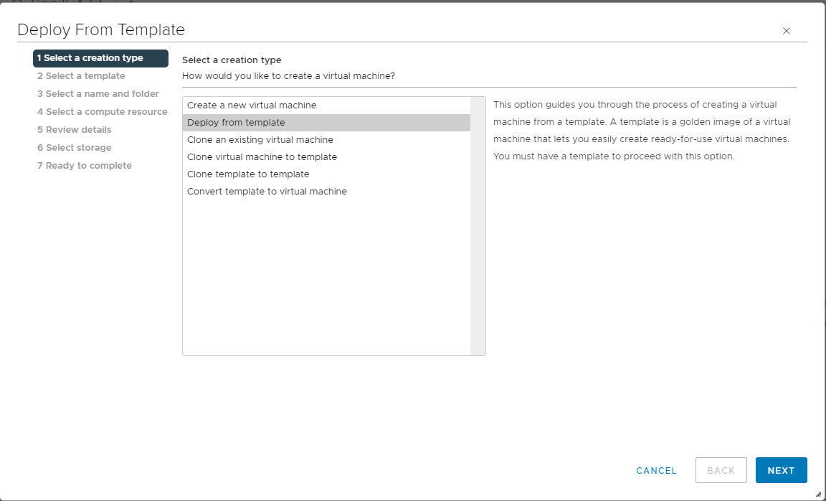

WIN_2019 GUI is selected as the template.

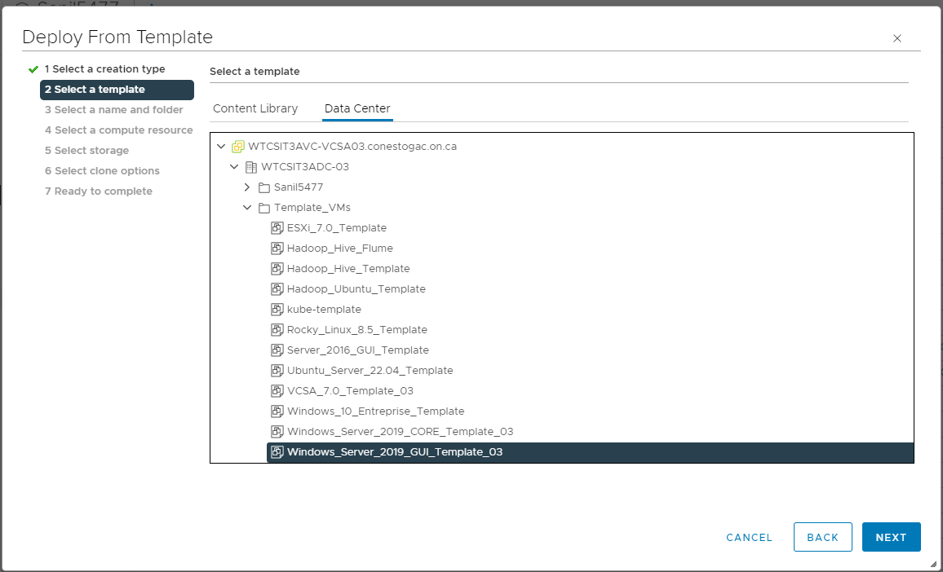

Gave the name for the target machine.

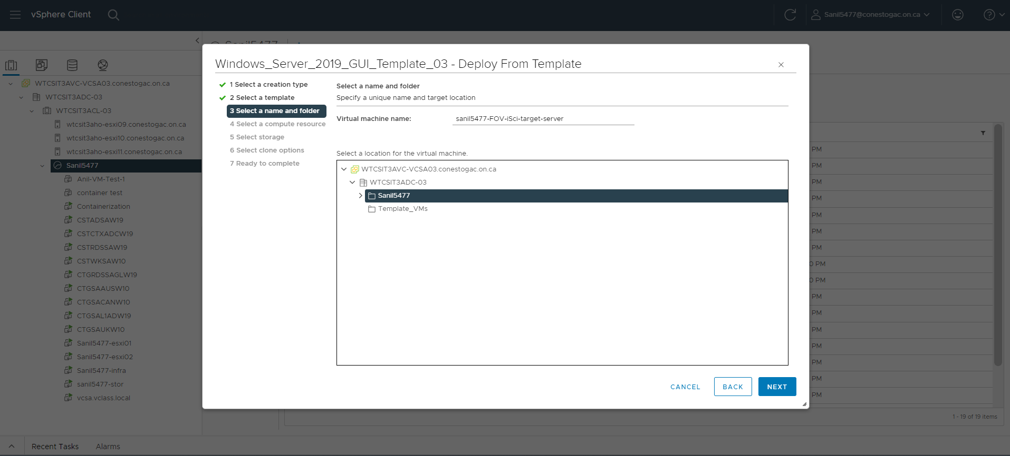

Selected the storage and selected the virtual disk format as Thin Provision

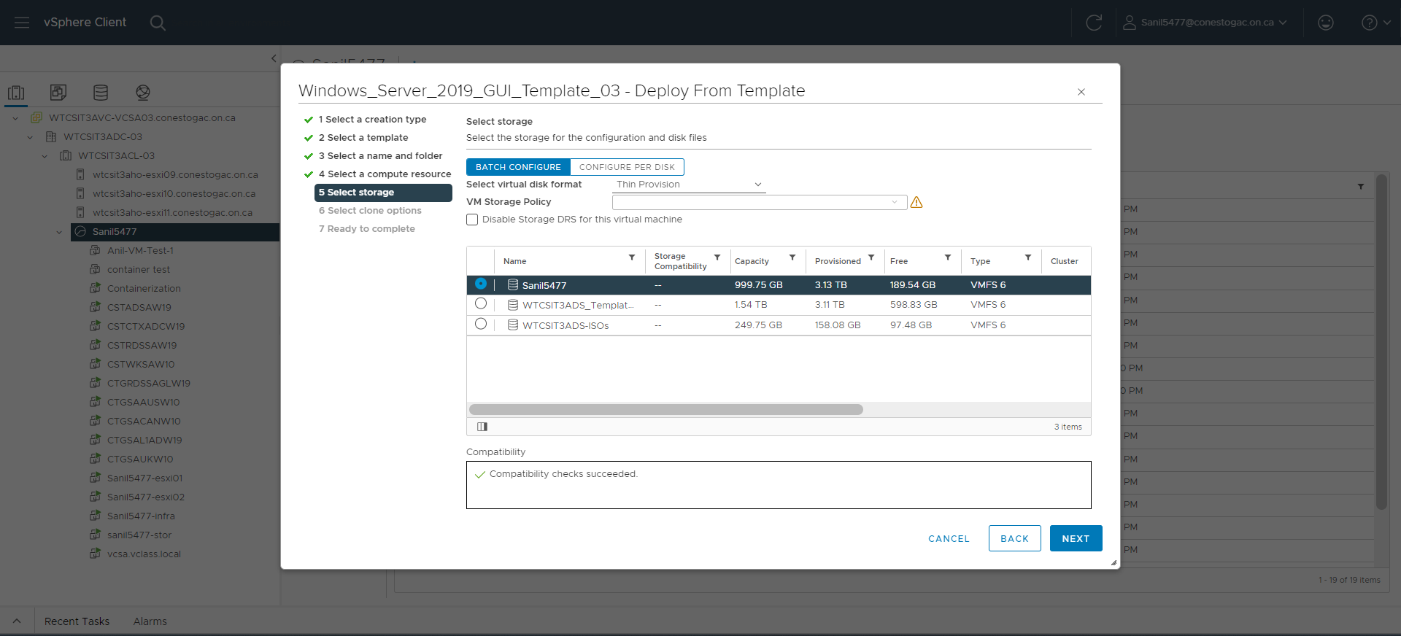

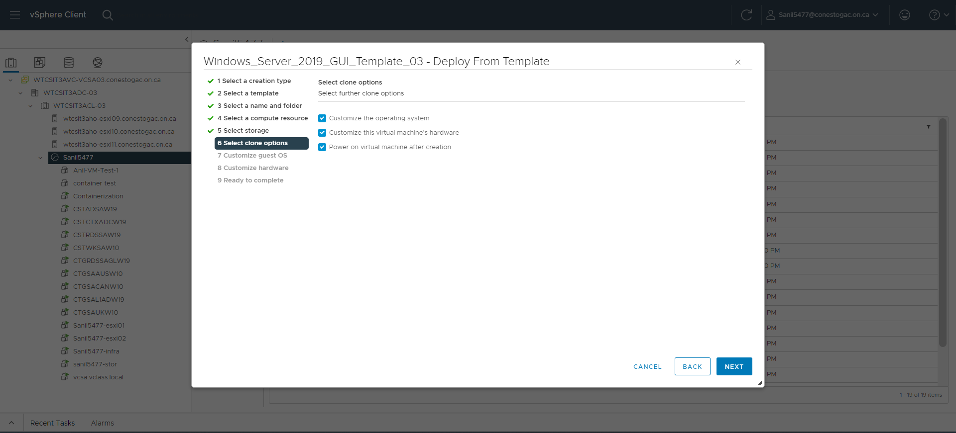

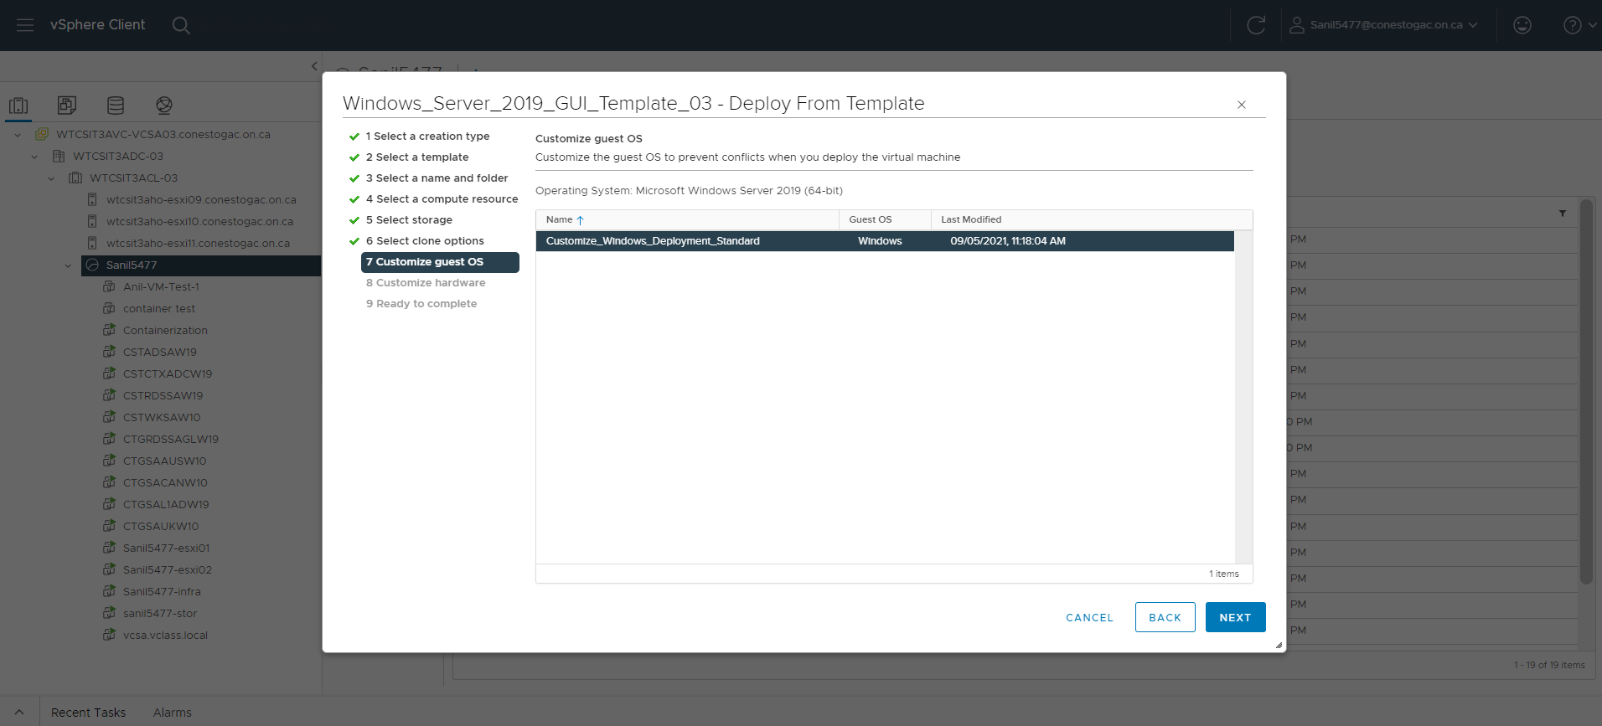

Provided the IP for Network Adapter Settings

IP for target server: 10.173.46.120

Subnet mask: 255.255.255.0

Gateway: 10.173.46.1

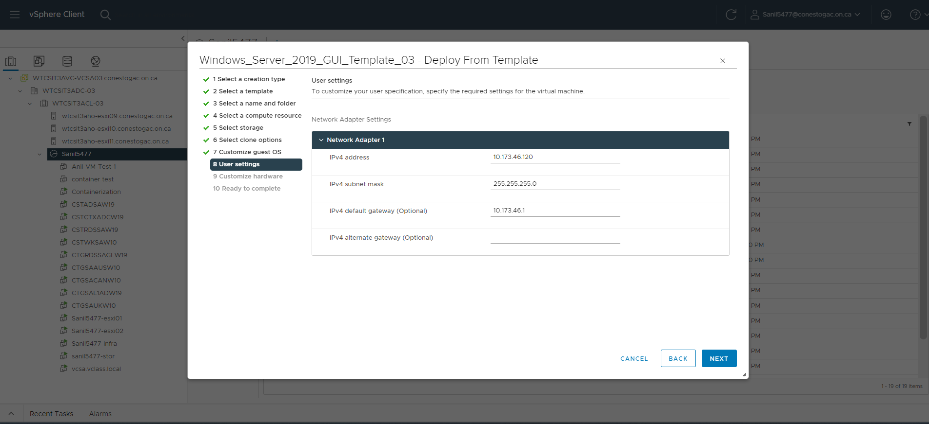

Customized the Hardware Requirements. Allocated sufficient resources:

CPU: 2

Memory: 8GB

Hard disk: 100GB

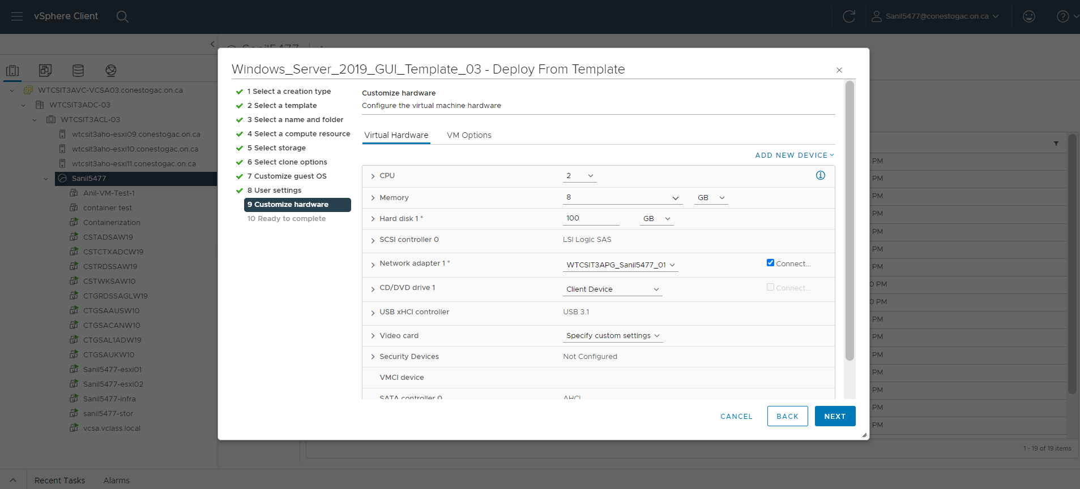

Verified the details.

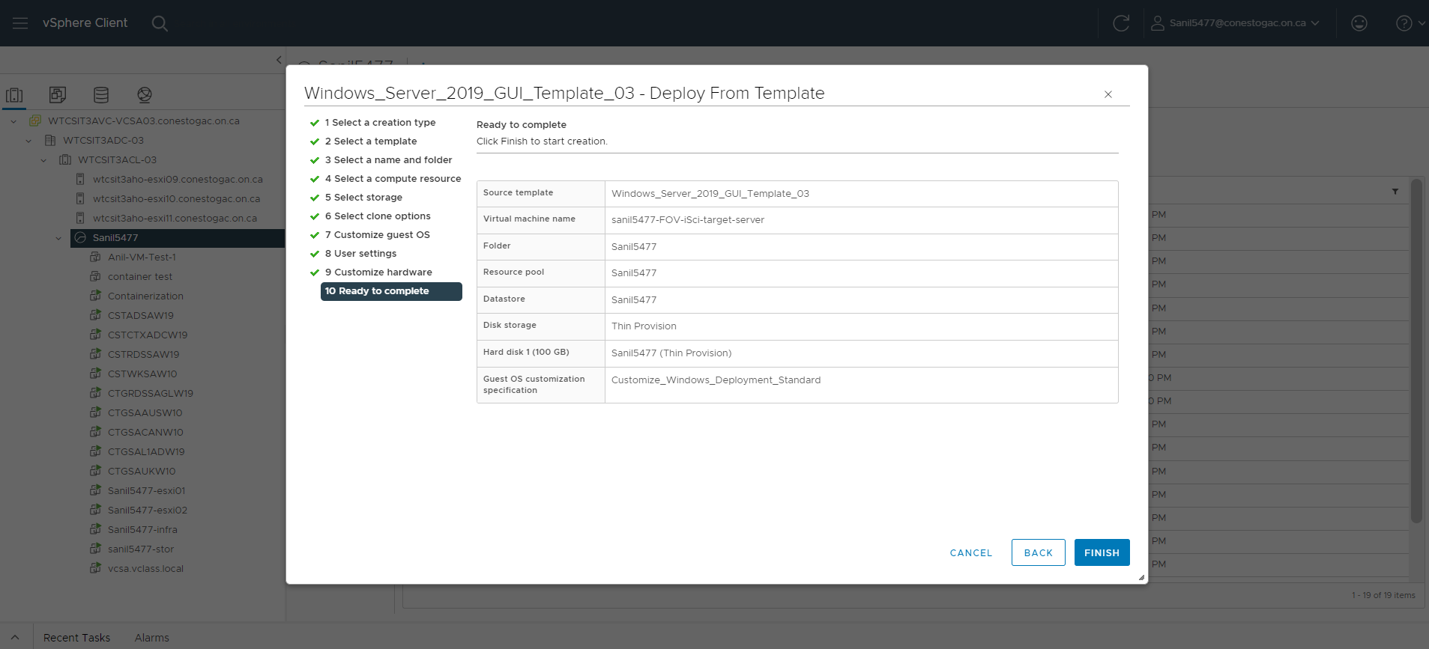

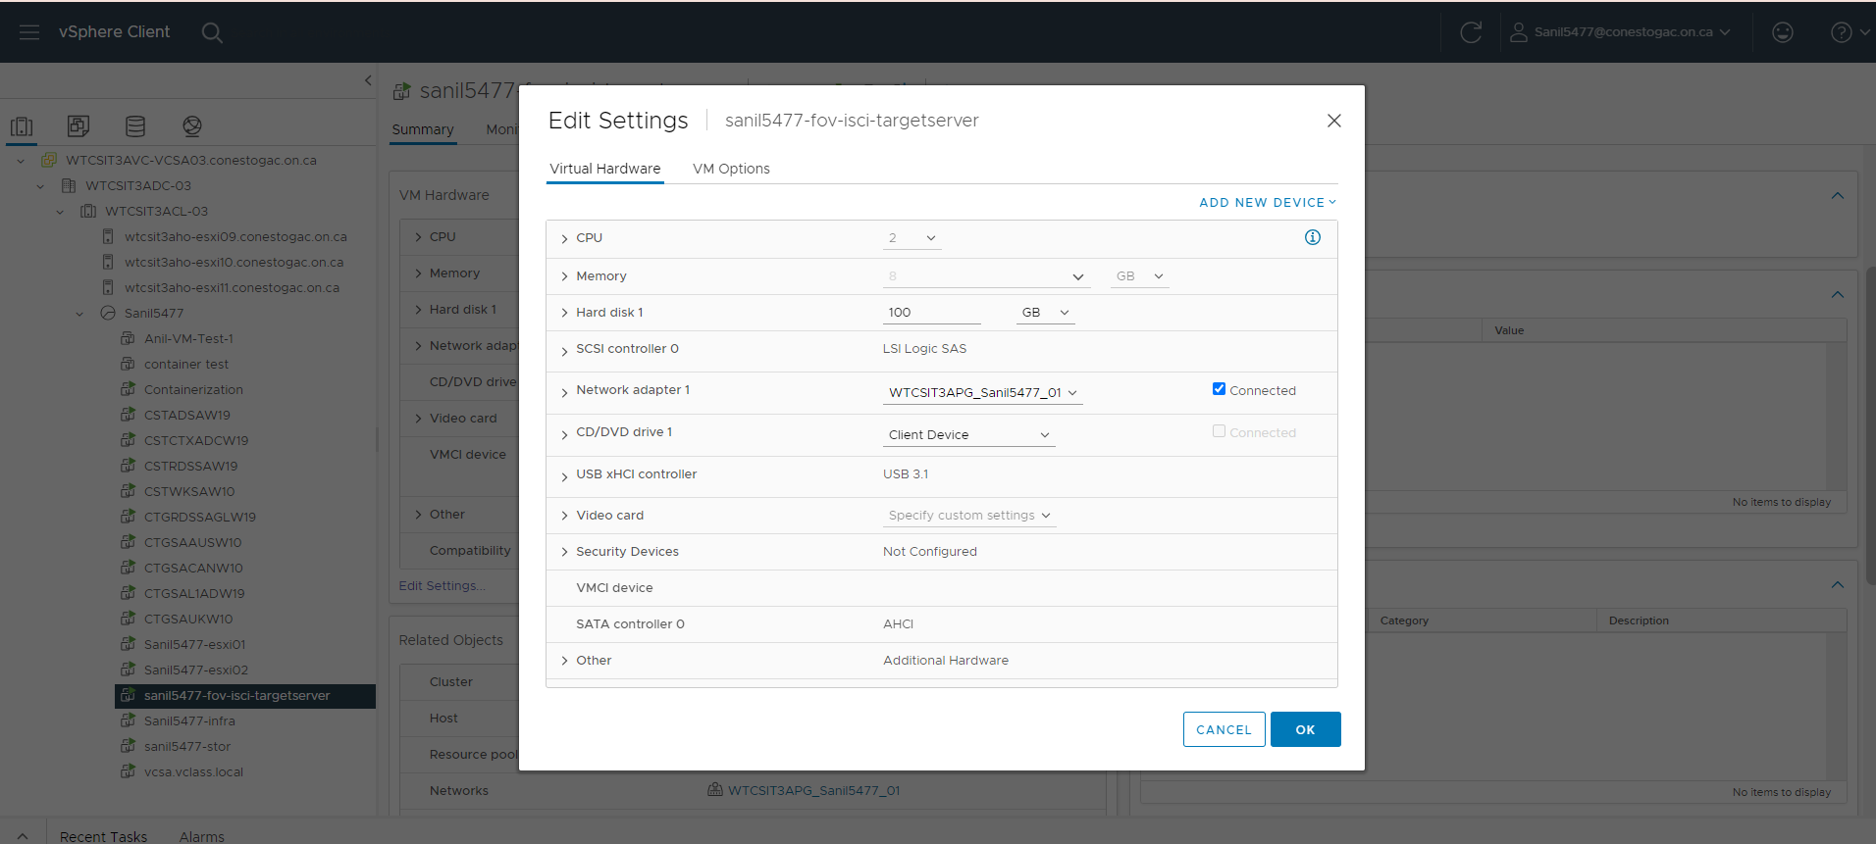

Task 2: Creating an iSCSI initiator

A piece of hardware or software that is installed on a server or host system is known as an iSCSI initiator. Its main objective is to establish communication with an iSCSI target, which is typically found on a storage device. In an iSCSI communication, the initiator represents the client. It notifies the iSCSI target of storage requests (such read or write commands). SCSI commands are encapsulated into iSCSI packets by initiators. (Margaret, 2021)

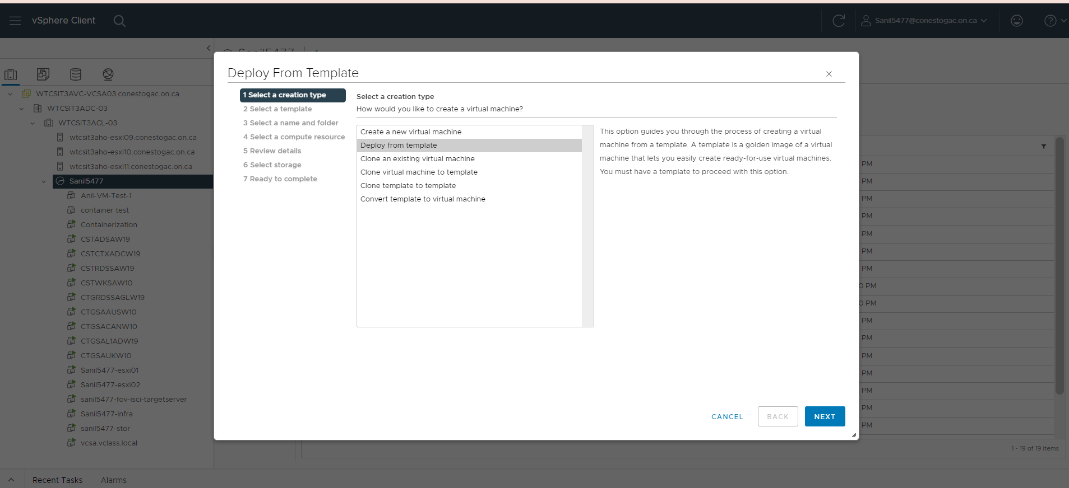

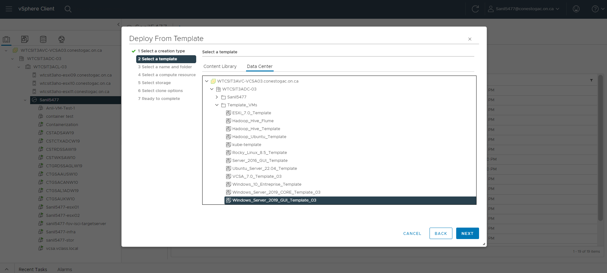

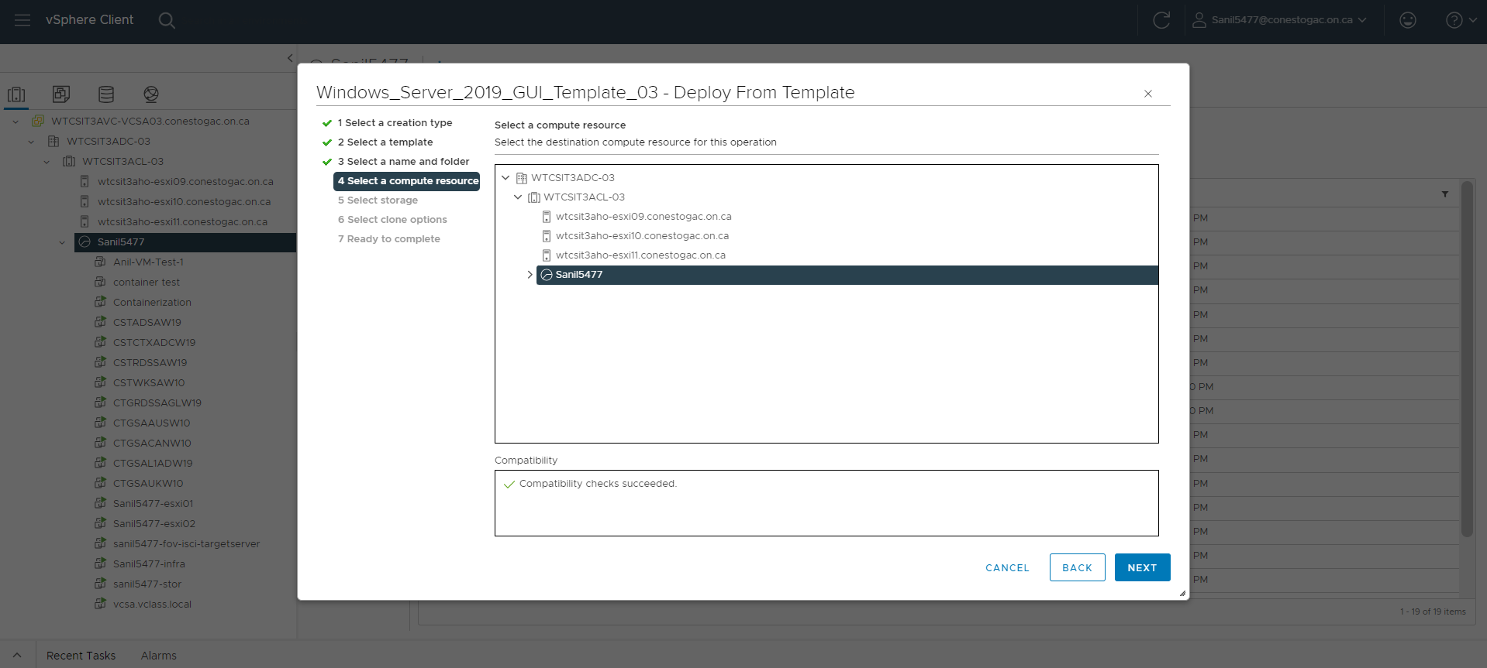

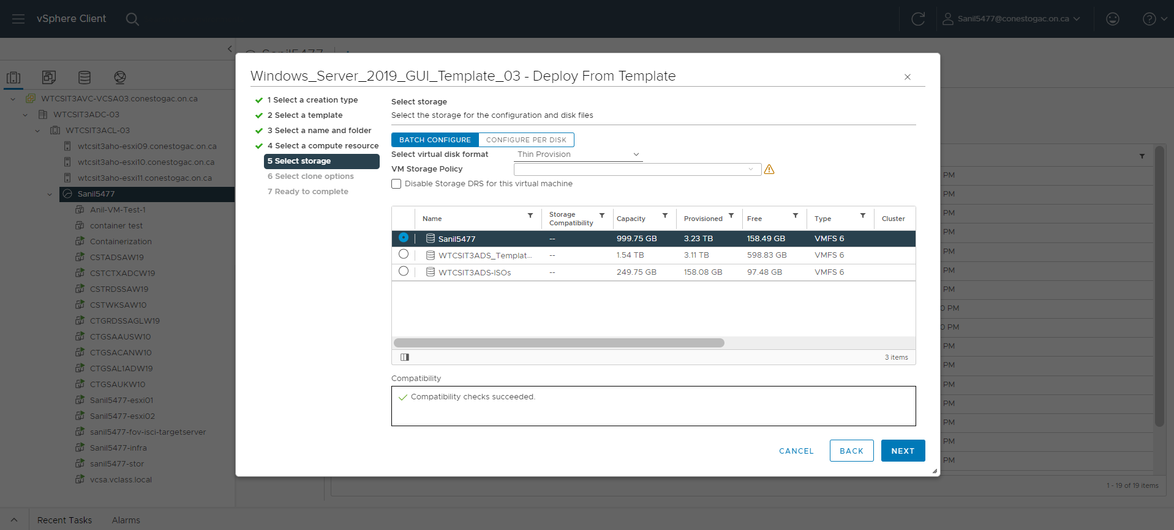

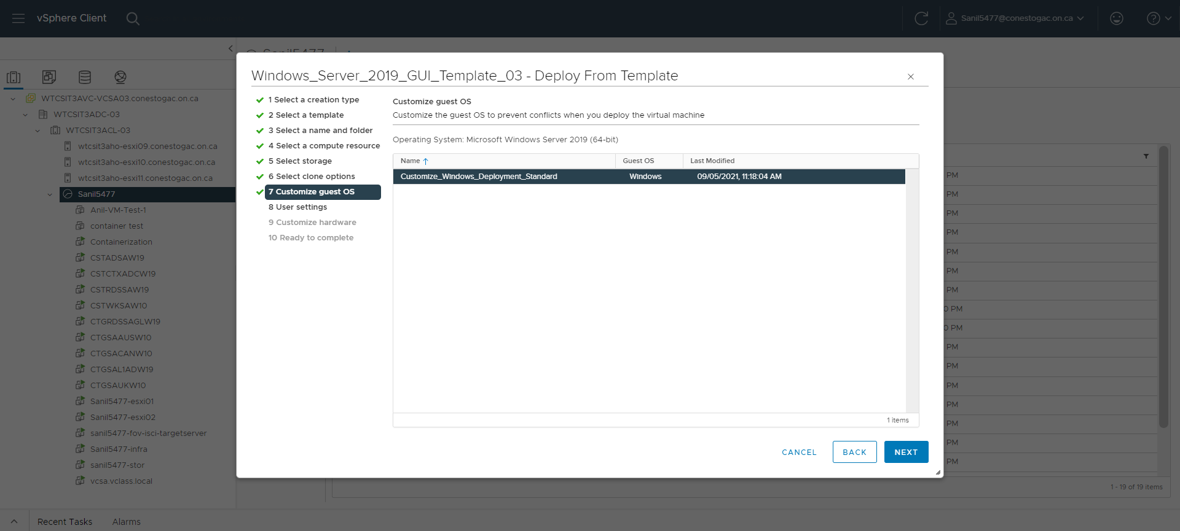

Provided the IP for Network Adapter Settings

IP for target server: 10.173.46.130

Subnet mask: 255.255.255.0

Gateway: 10.173.46.1

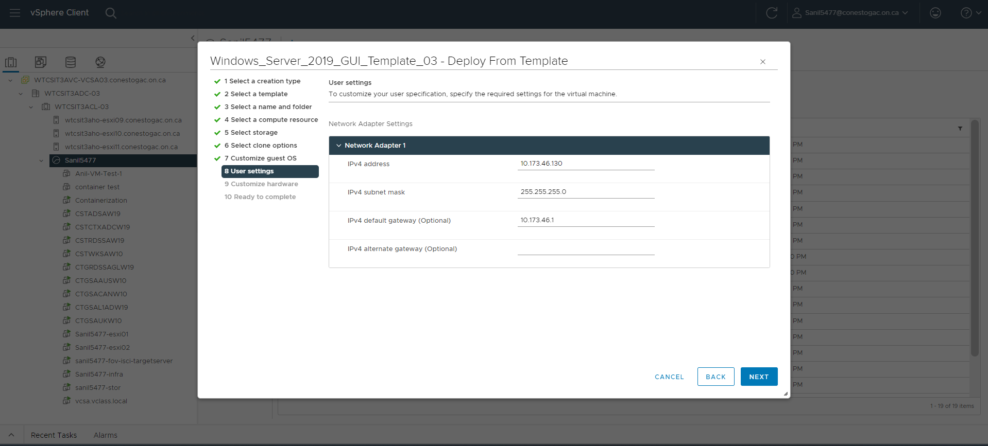

Customized the Hardware Requirements. Allocated sufficient resources:

CPU: 2

Memory: 8GB

Hard disk: 100GB

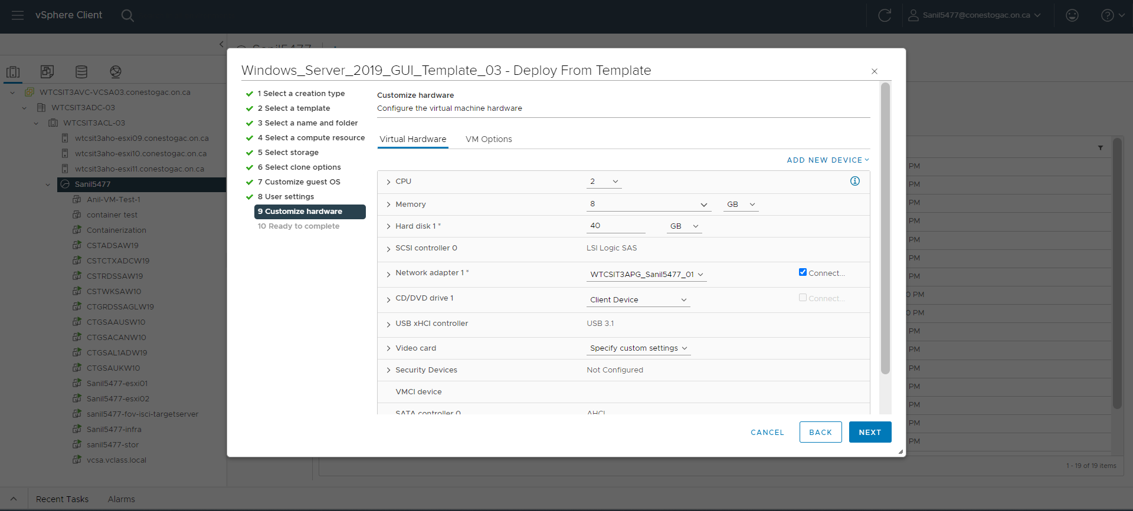

Verified the final setting.

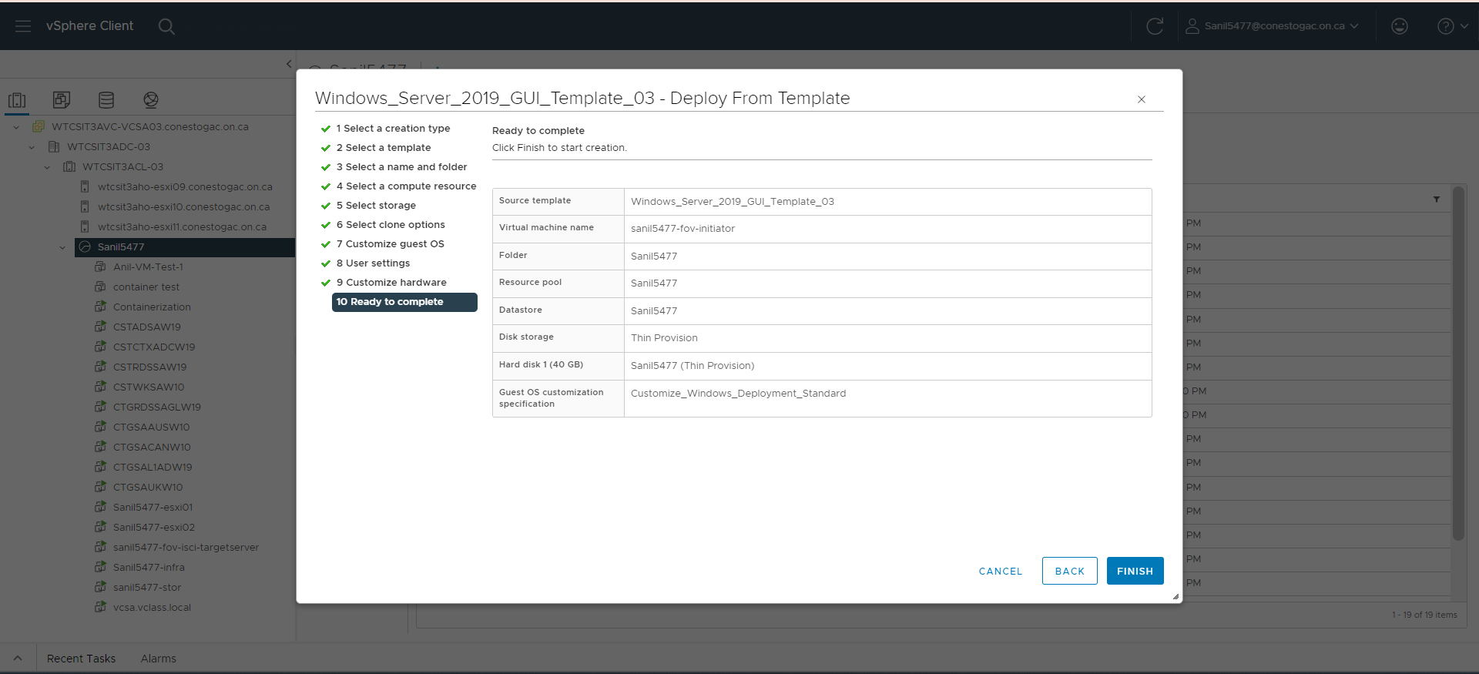

Target Server Created

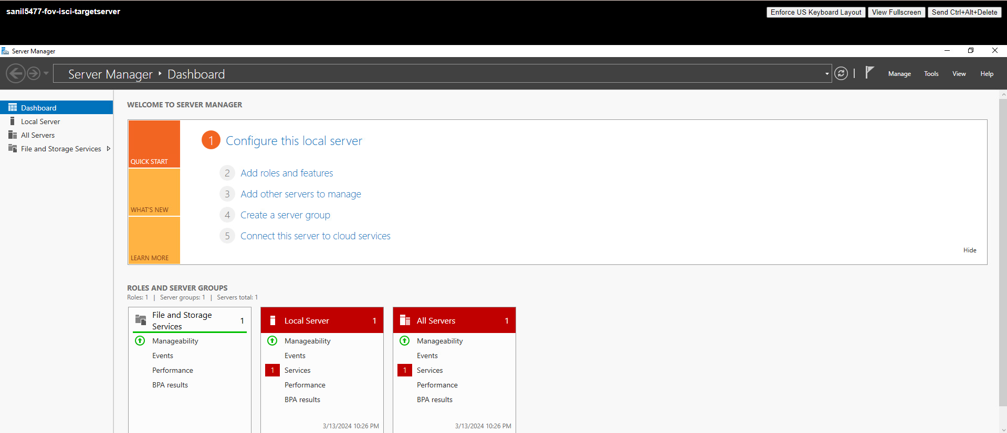

Initiator Machine Created

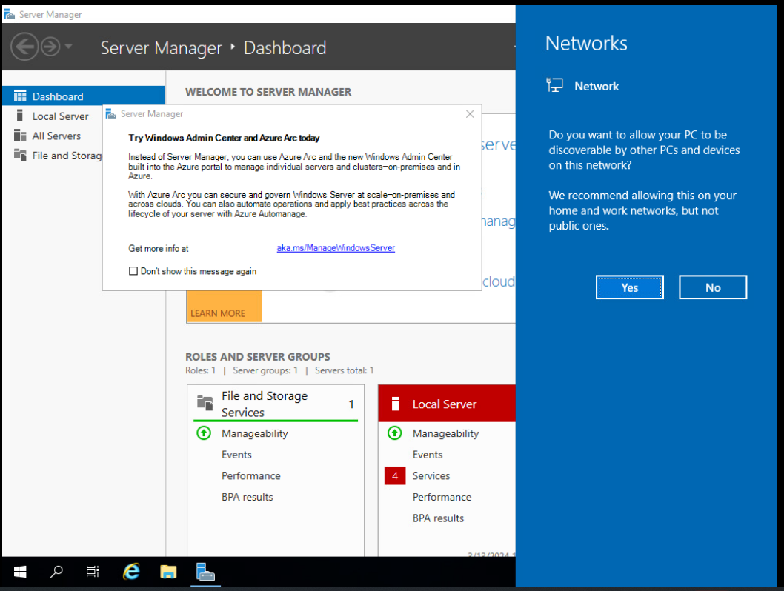

Task 3: Creating the ISCSI target server

The benefits of giving a target server the function of an iSCSI connection. iSCSI connection setup results in a strong storage system with a number of benefits. A centralized storage system is established by establishing an iSCSI connection between client computers and a dedicated storage server. This shared storage area is accessible to all clients just like a local hard drive would be. Data backup, maintenance, and management are made easier by centralization. You can effectively pool storage resources via iSCSI. Depending on demand, storage space can be allocated dynamically. Any system that is connected can access unused storage; it is not restricted to any client. (Lowe, 2007)

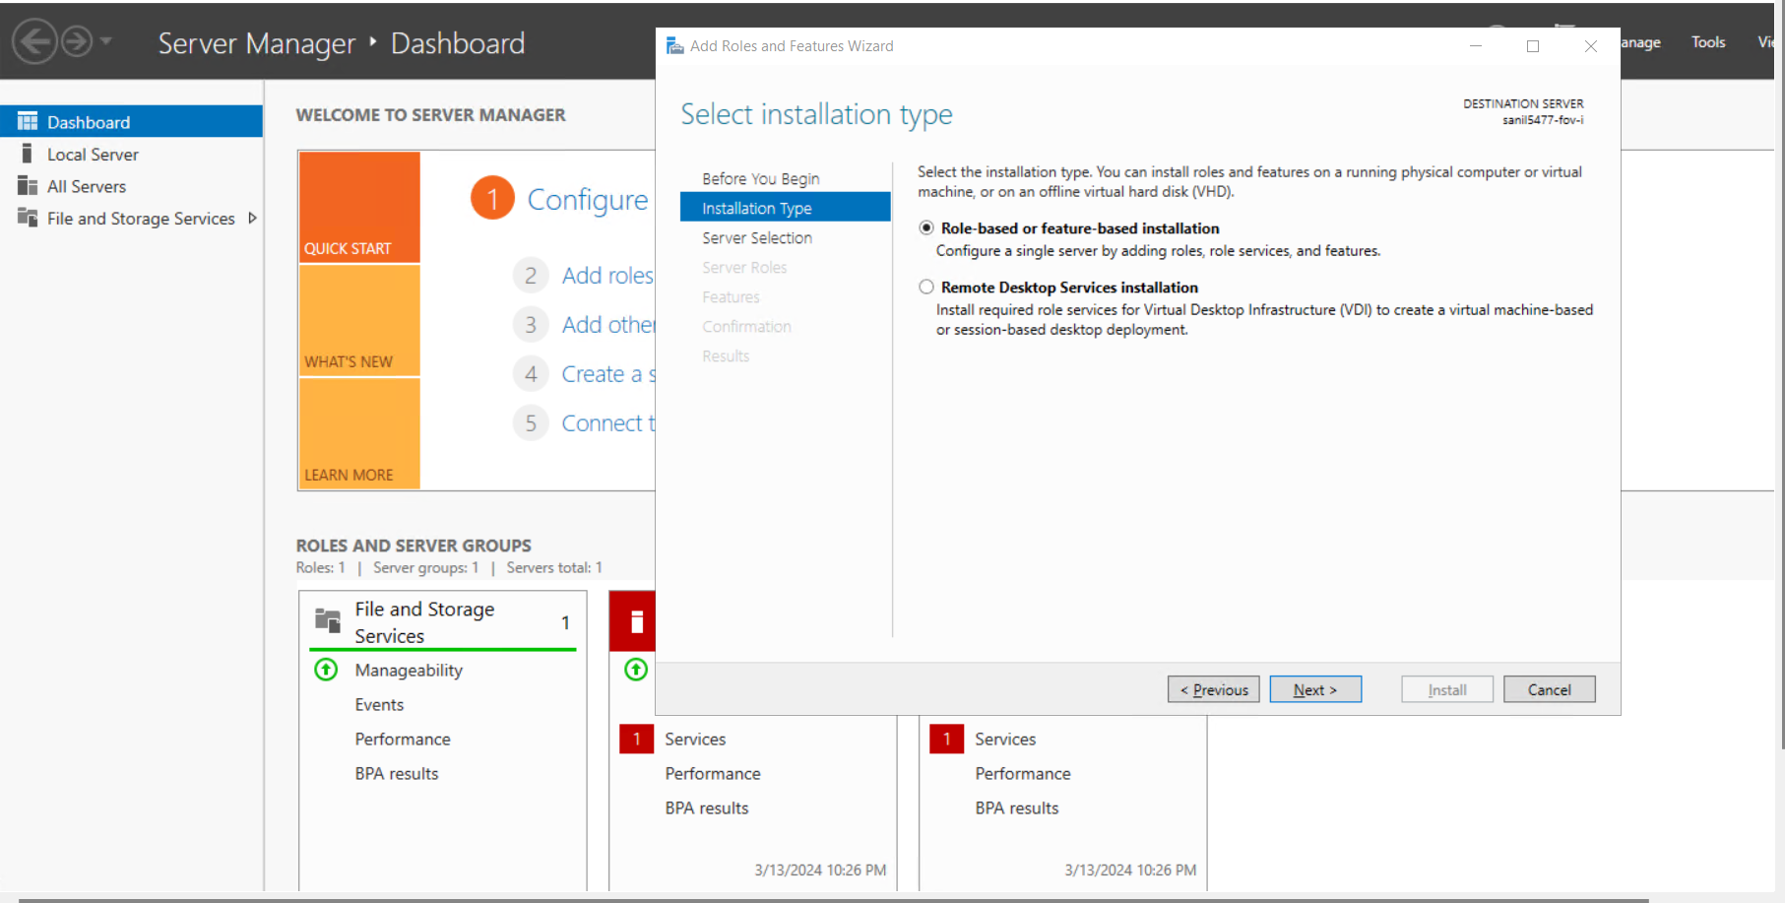

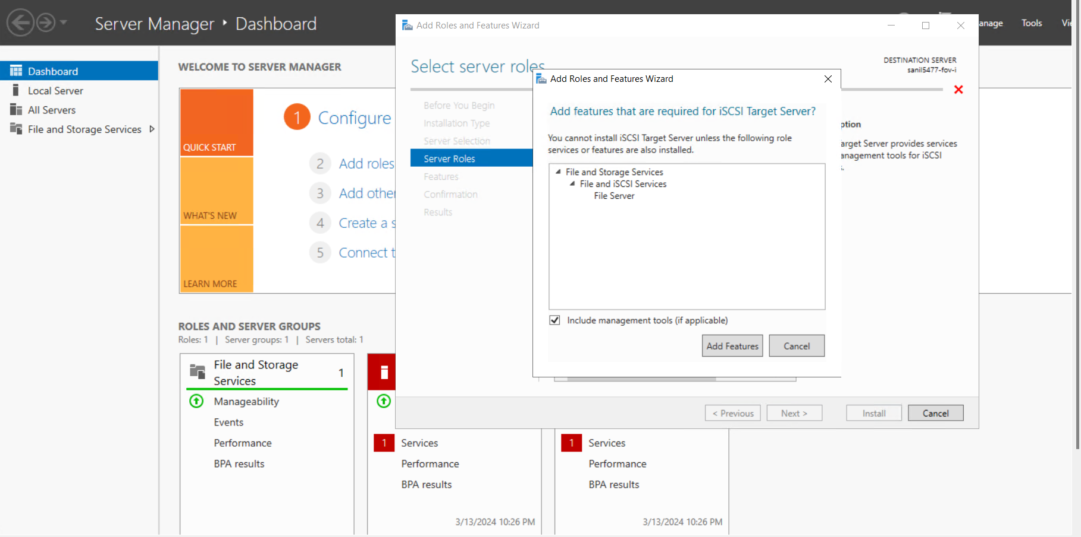

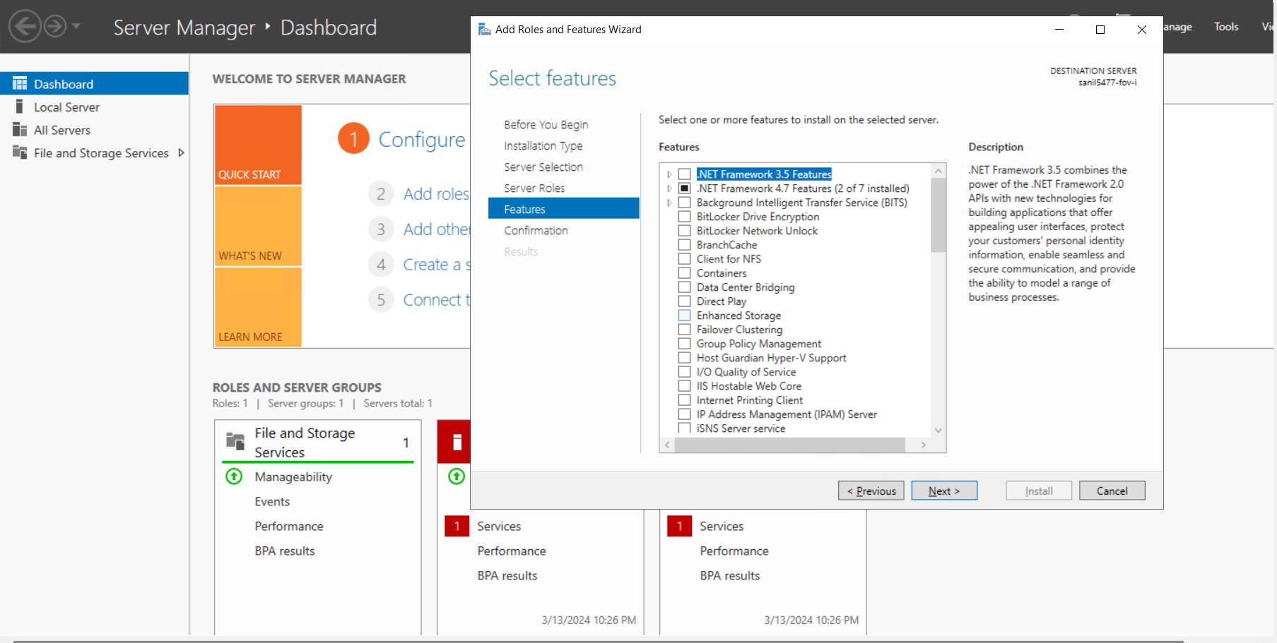

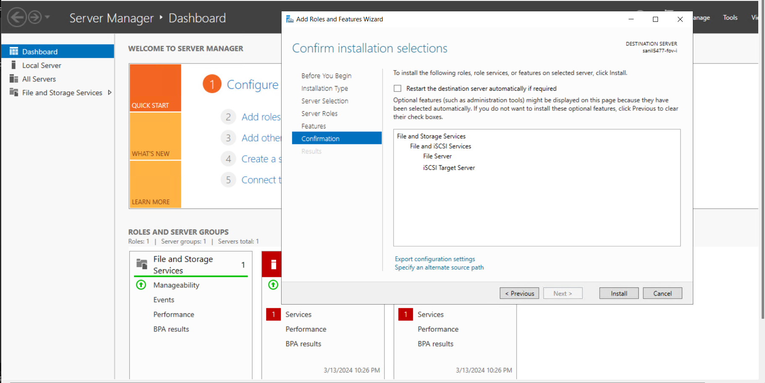

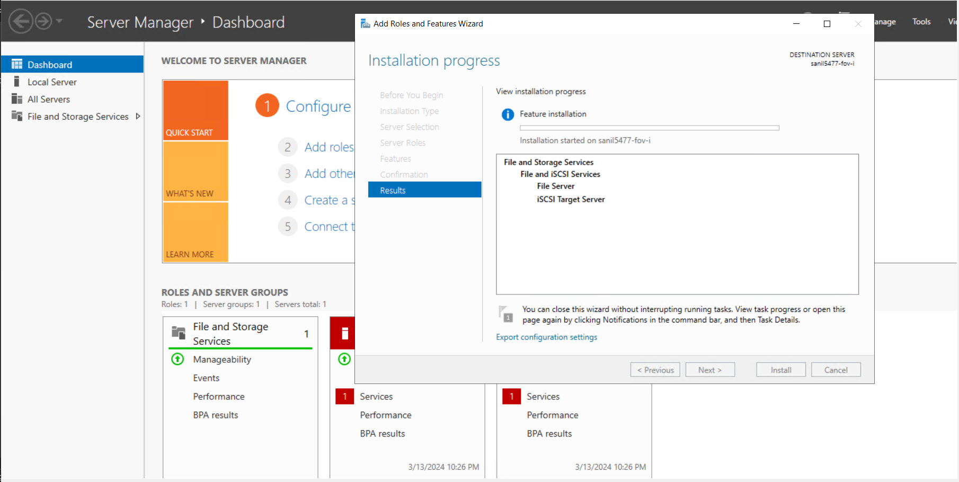

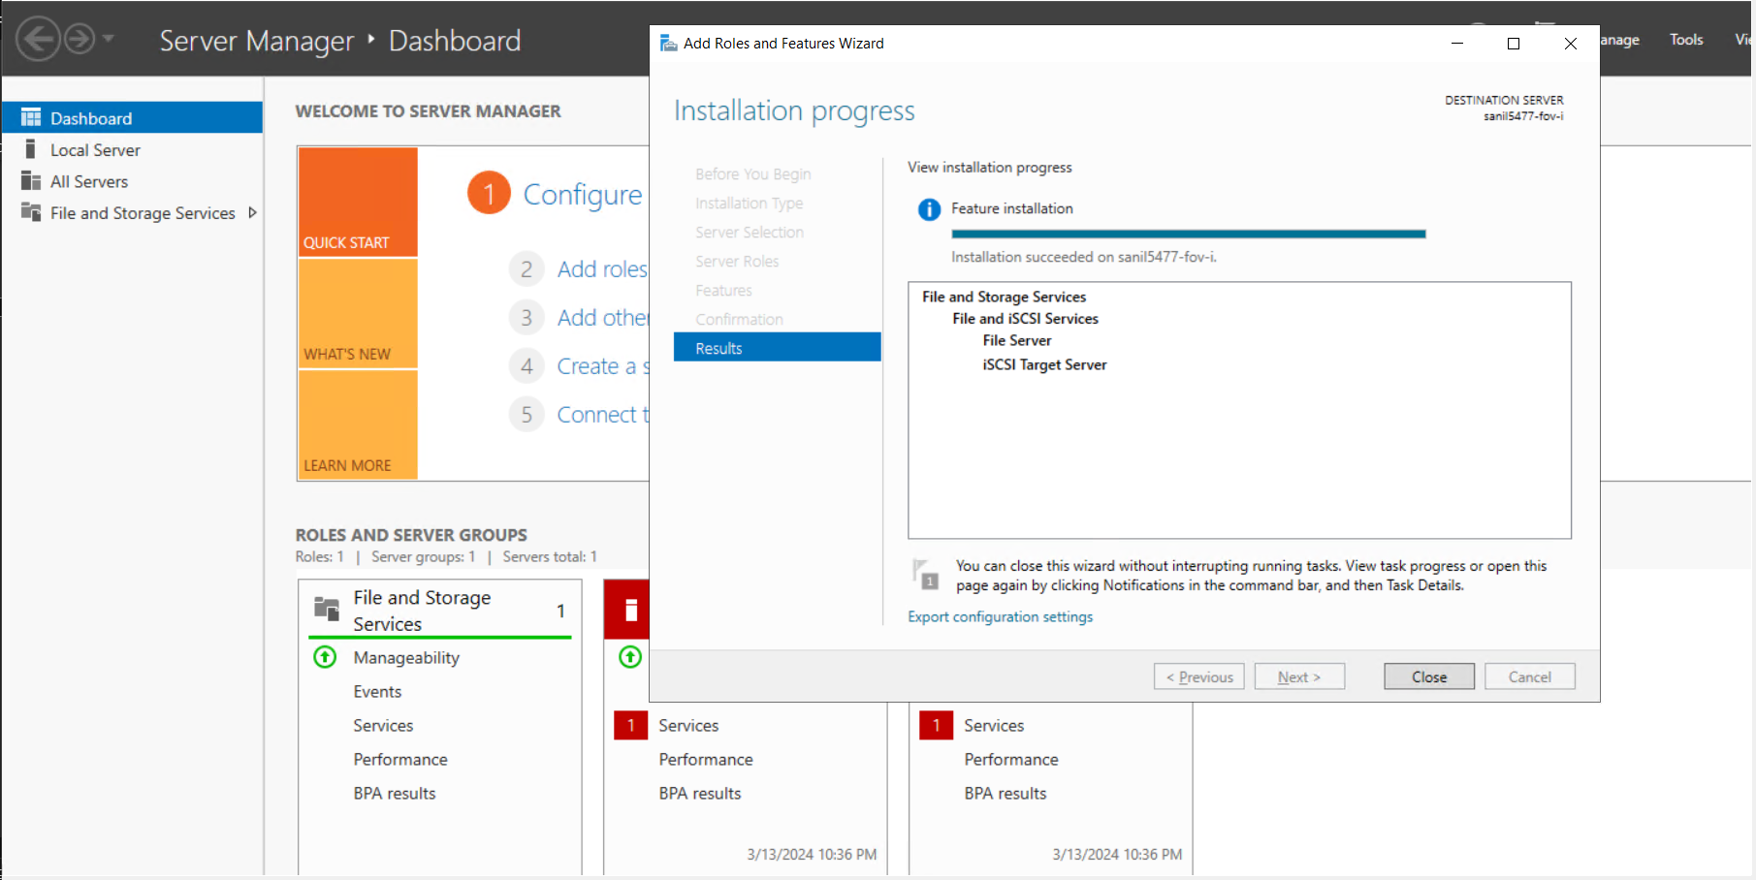

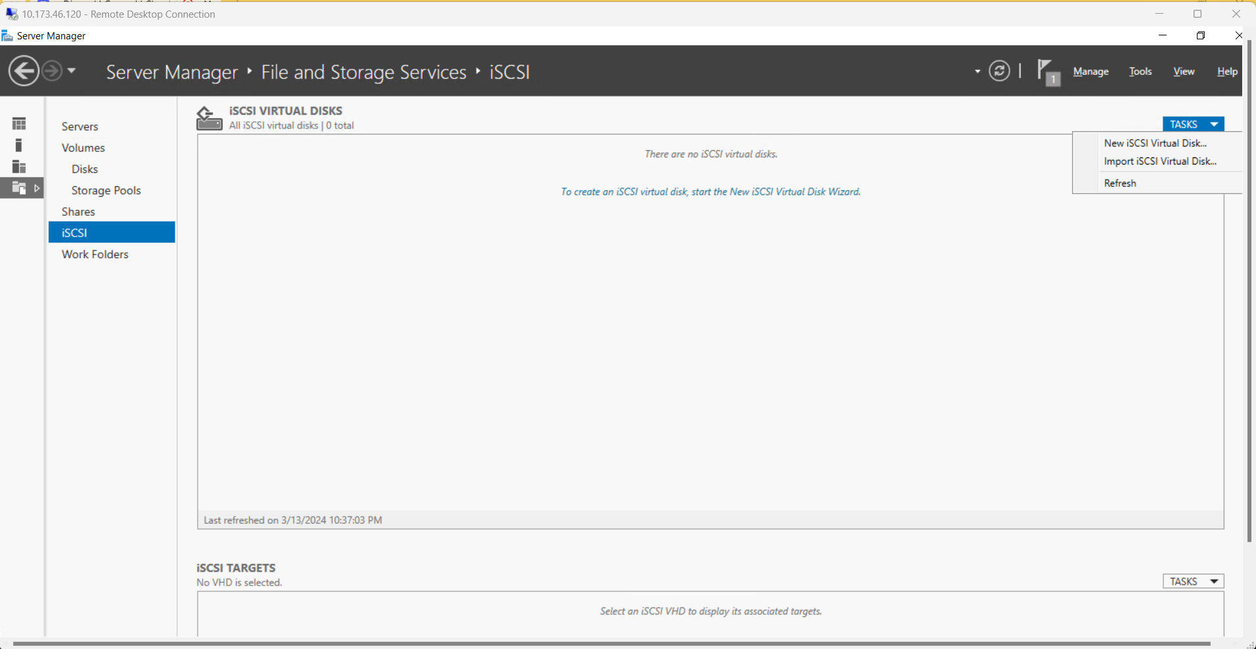

Specifying the Virtual Disk Location

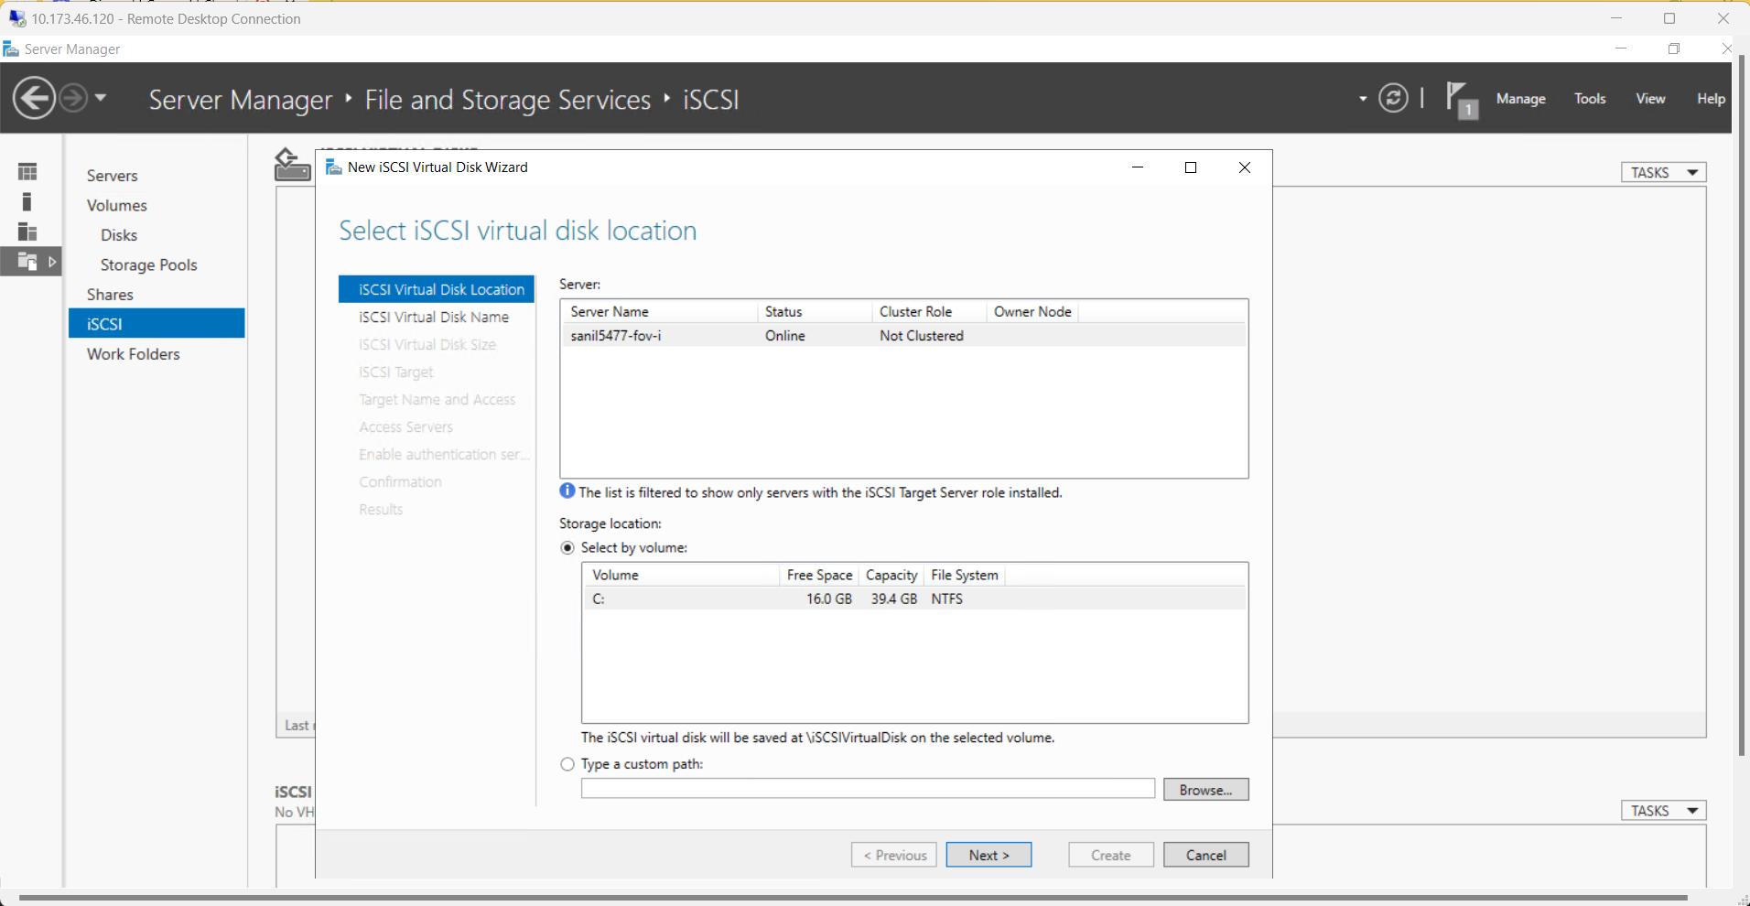

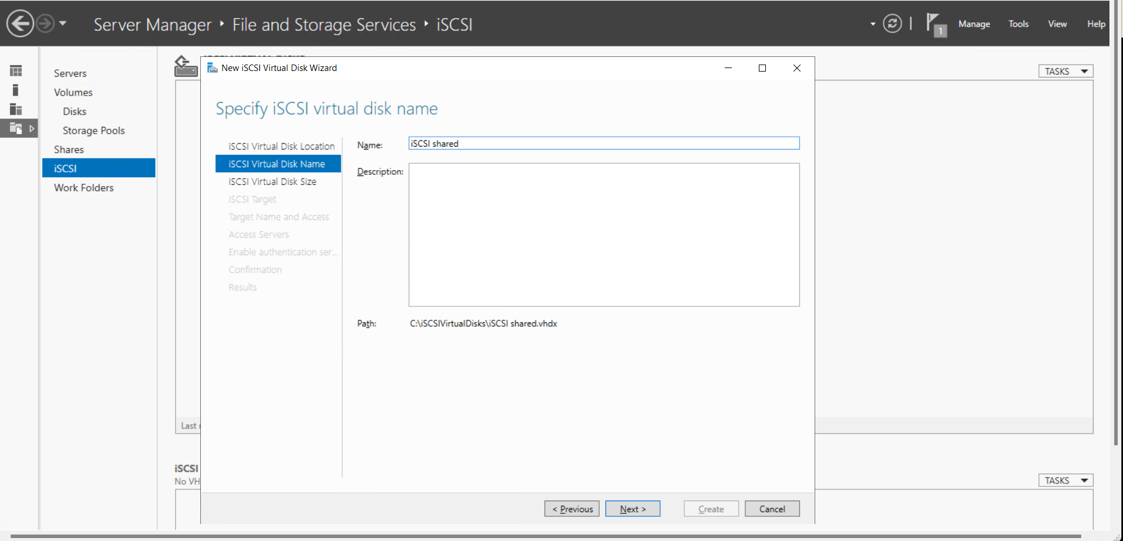

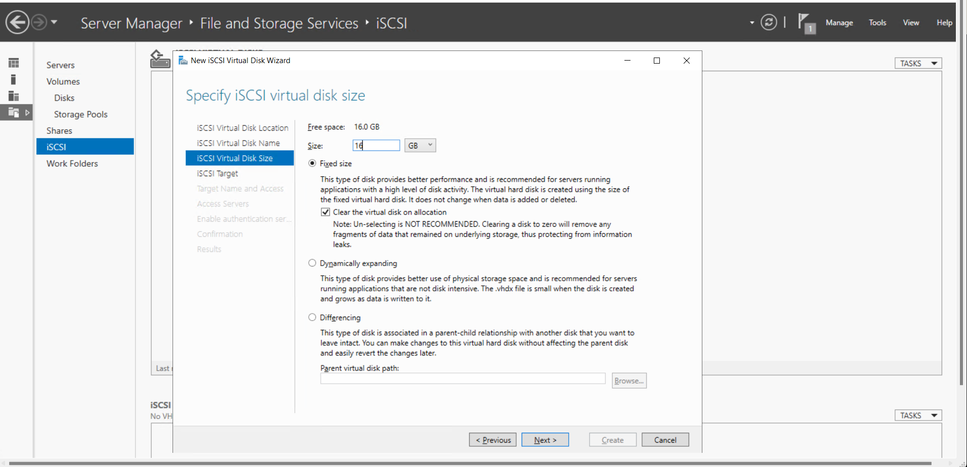

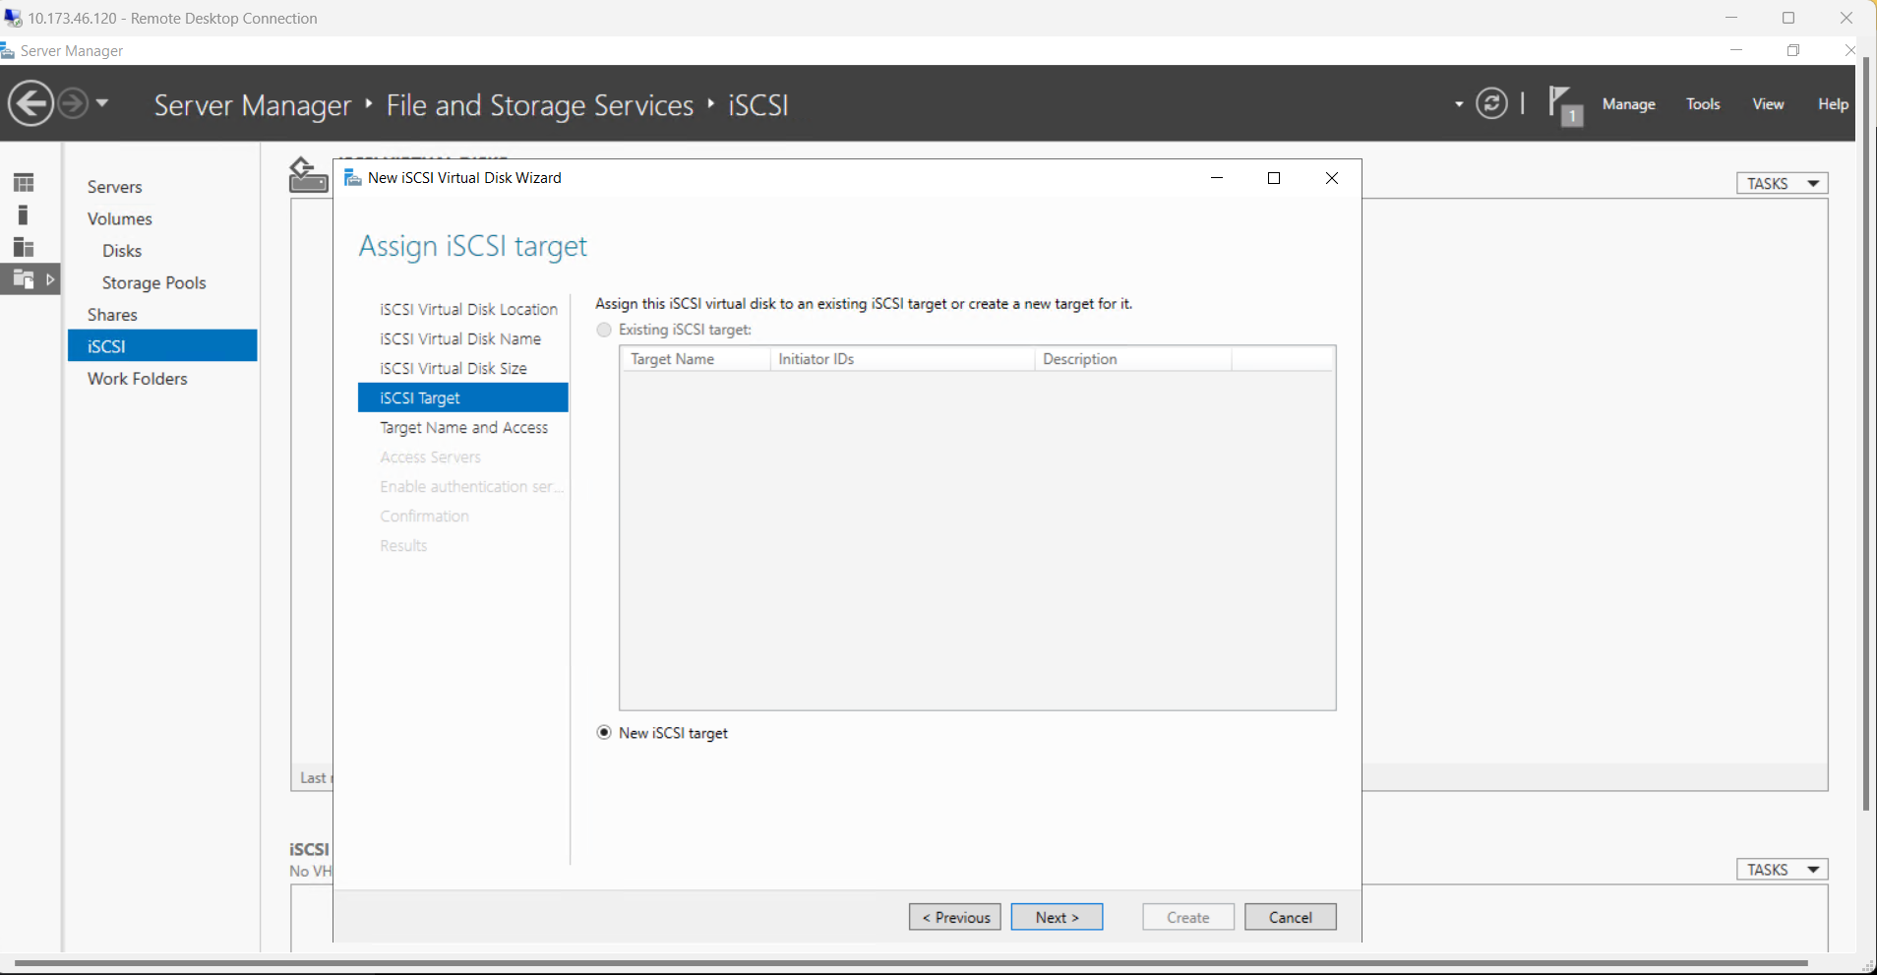

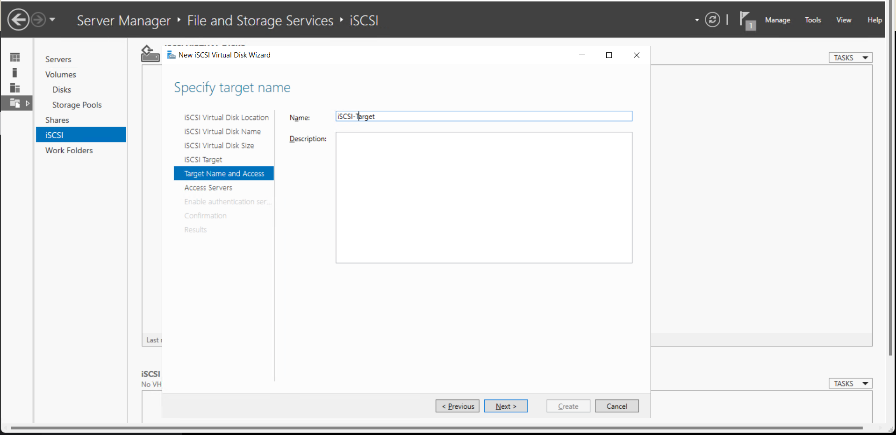

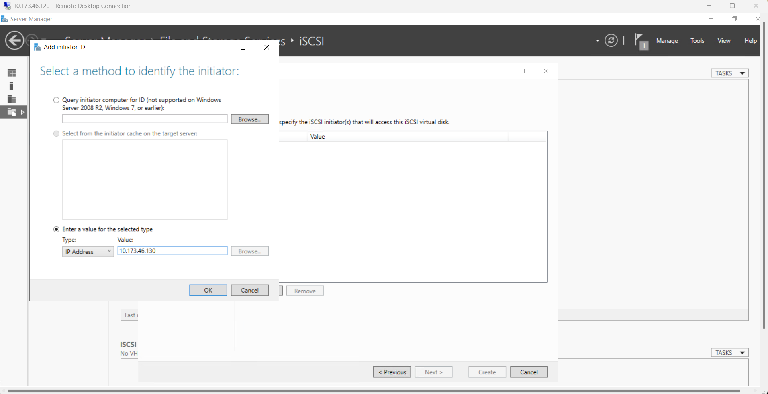

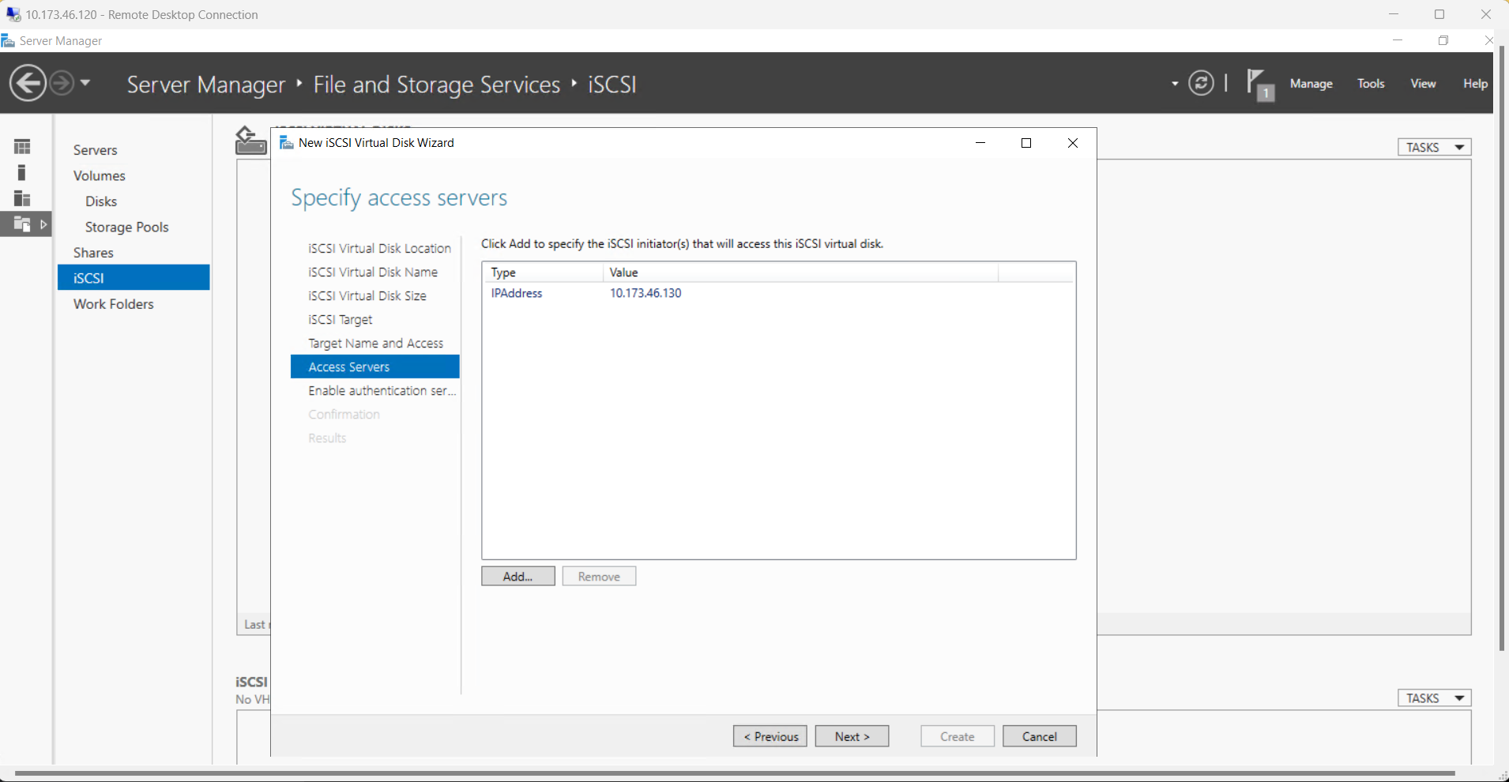

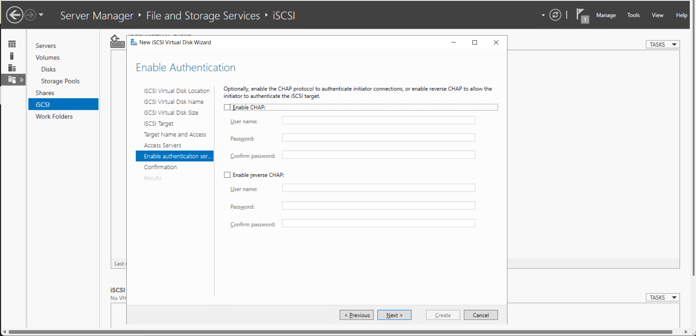

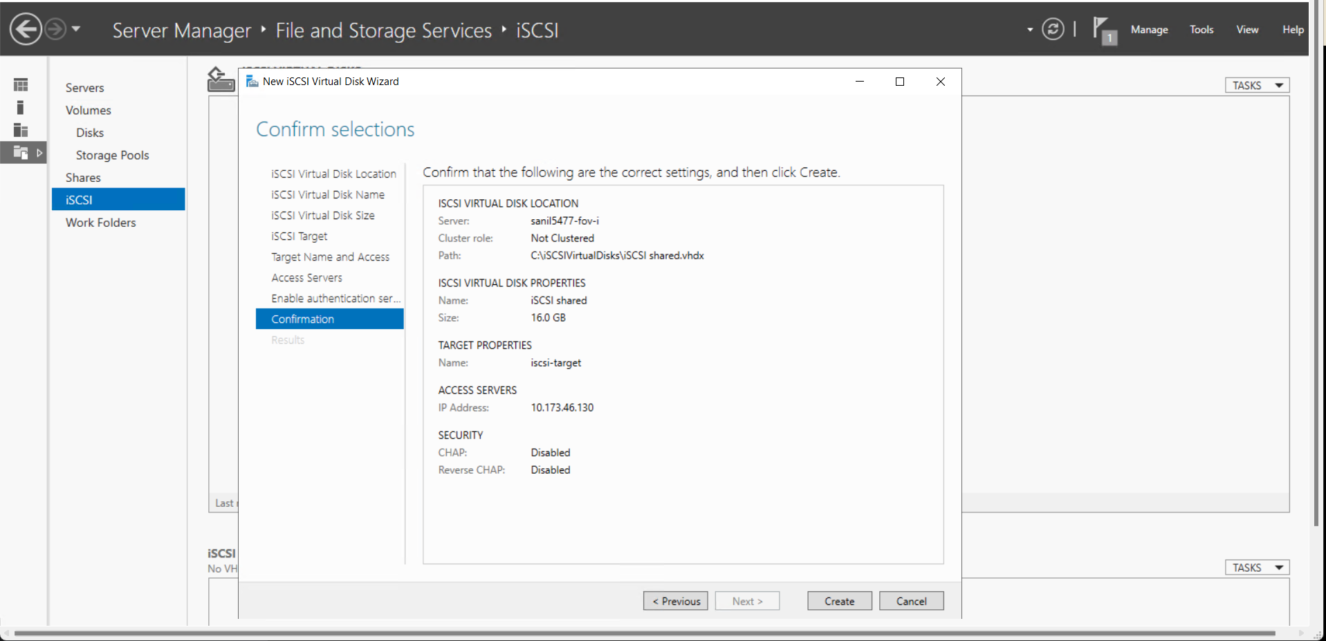

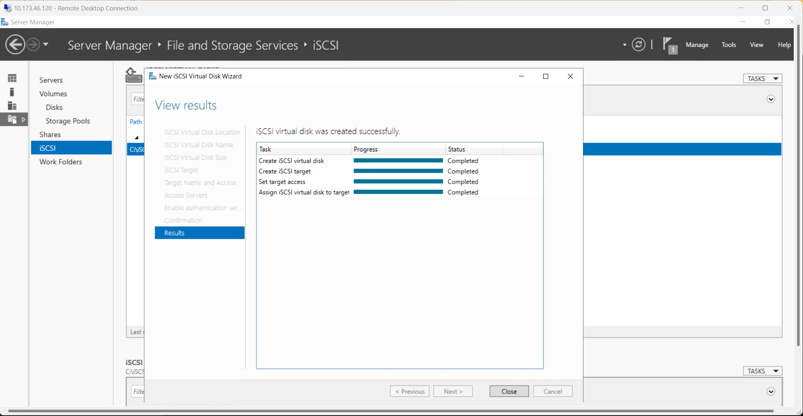

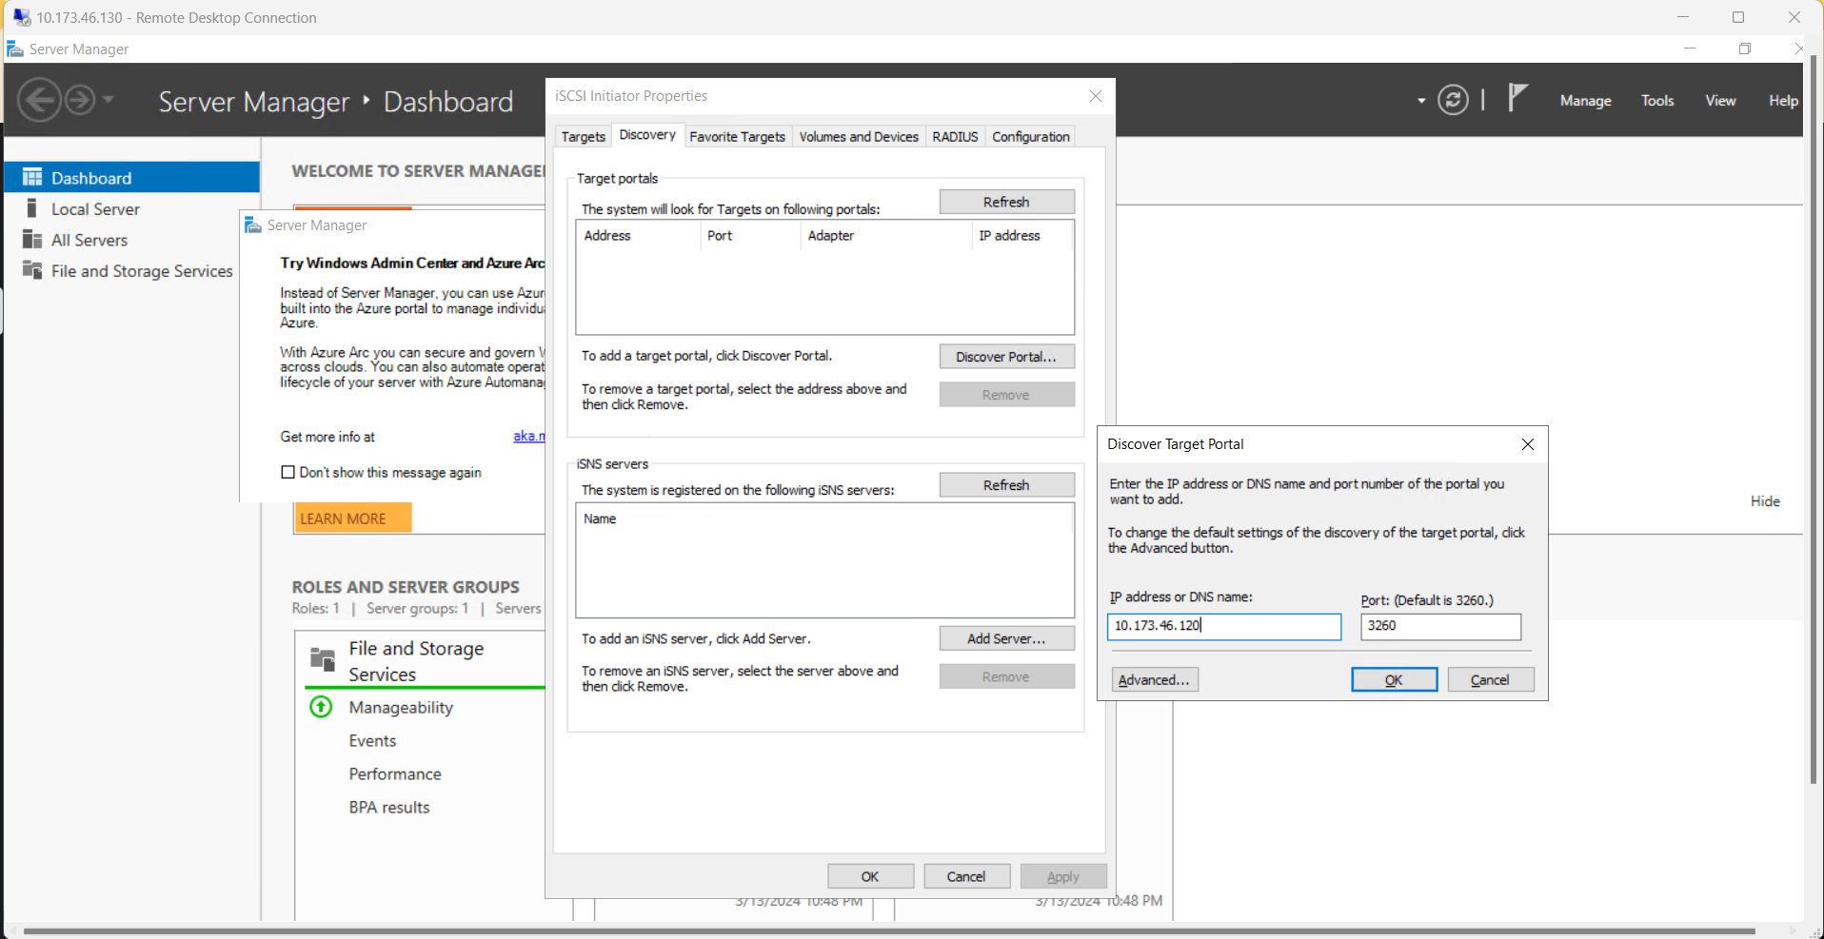

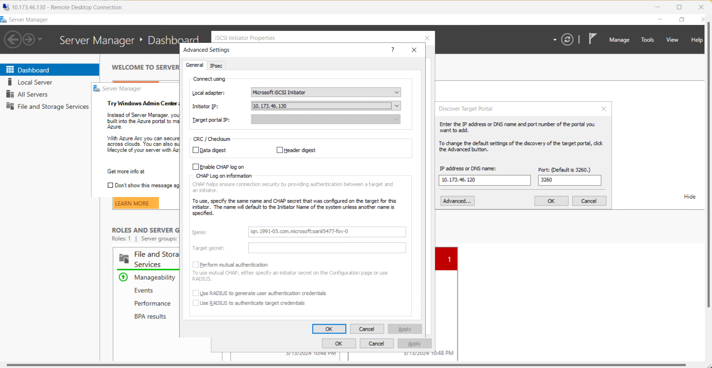

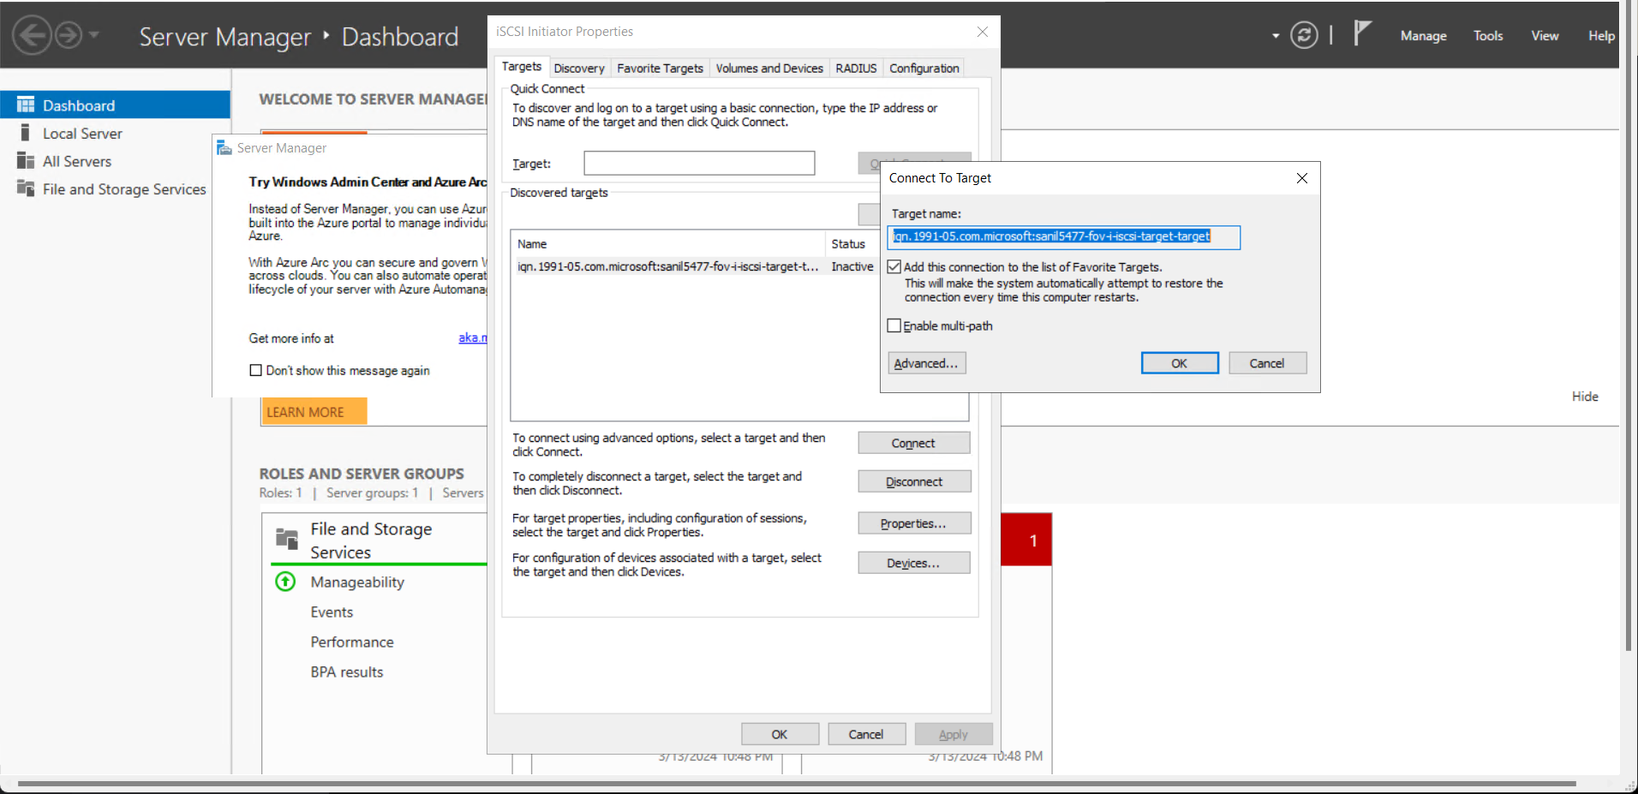

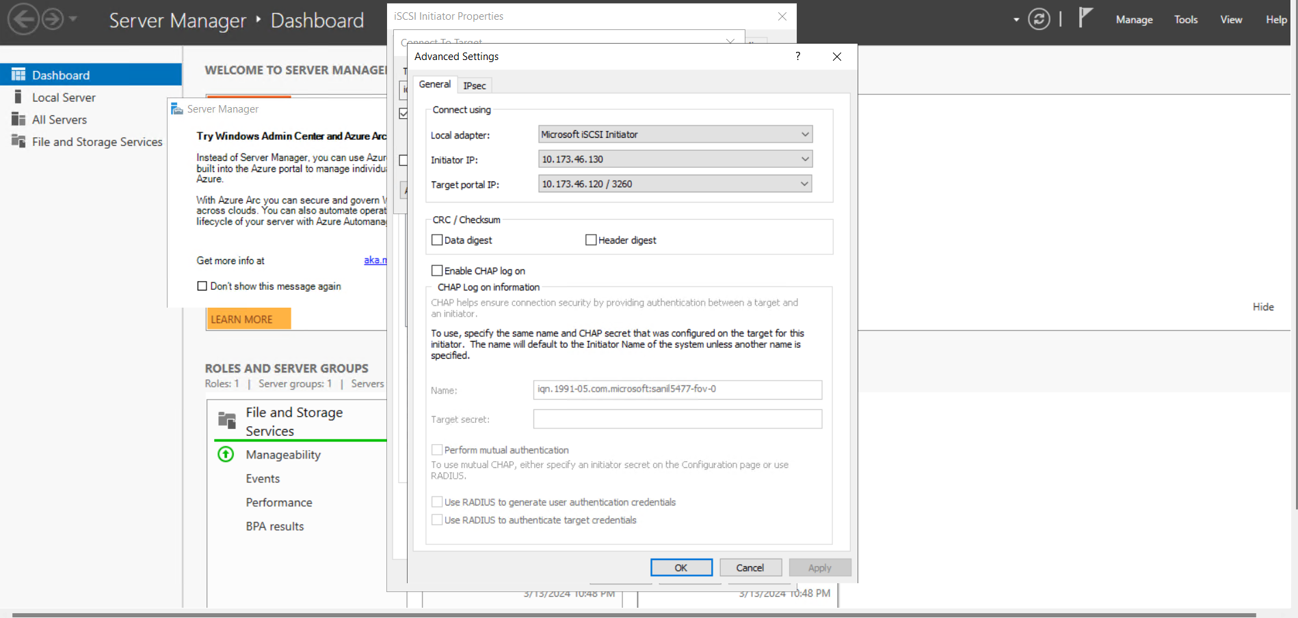

Initiator is connected to target server.

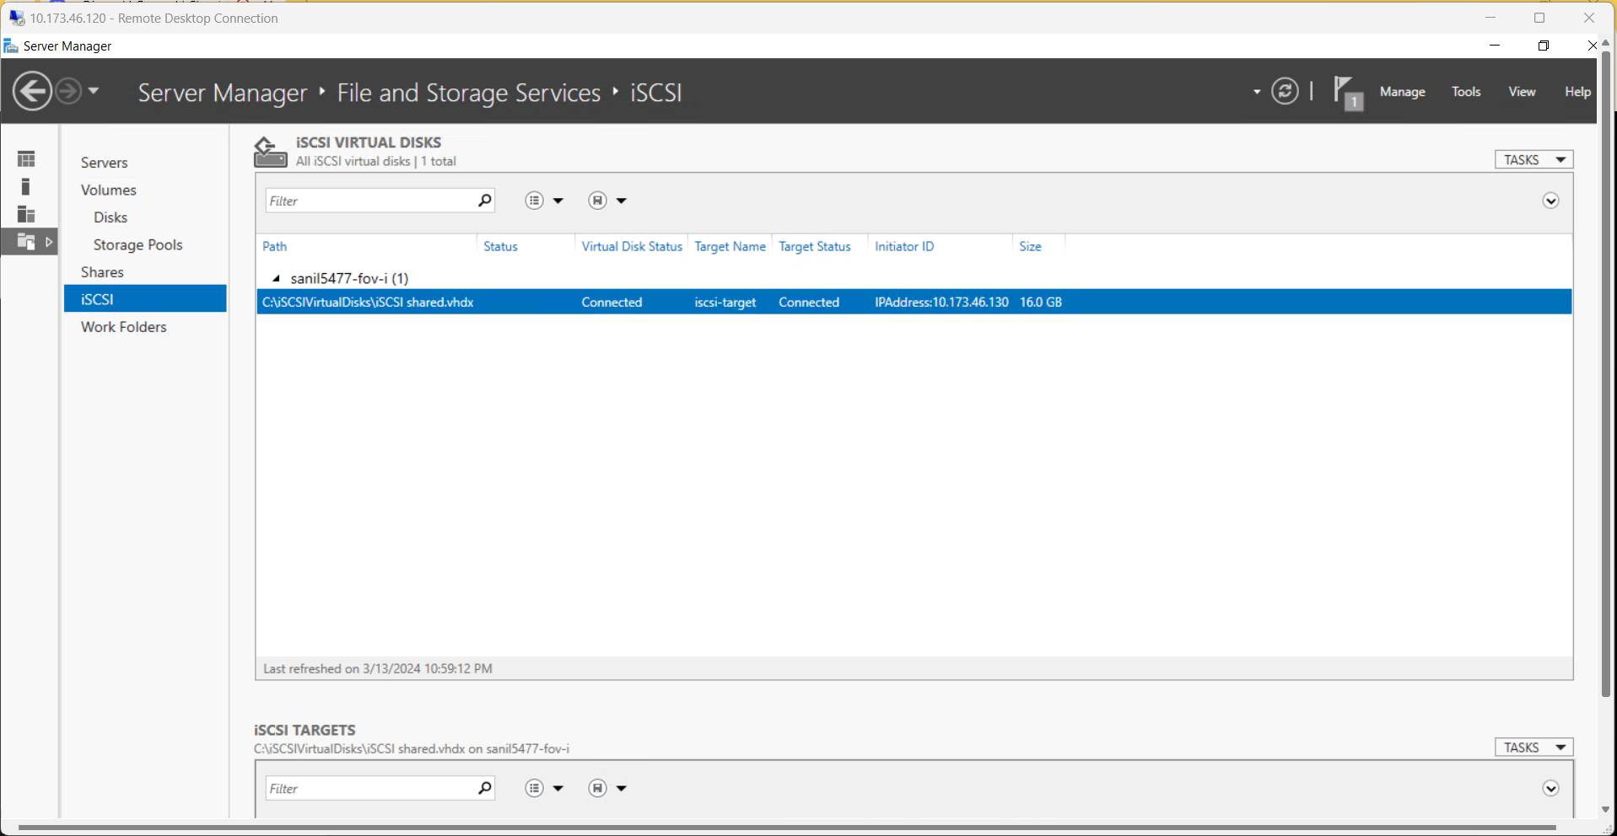

Task 4: Disk partition on initiator Machine

Partitioning a physical disk entail breaking it up into smaller sections, or partitions. Every partition functions similarly to a distinct disk, complete with its own file system and storage capacity. (Upadhyay, 2020)

Commands Applied:

**Diskpart**

**San**

**Online all**

**Attributes disk**

**Select disk 1**

**Attributes dusk clear read only**

**Online disk**

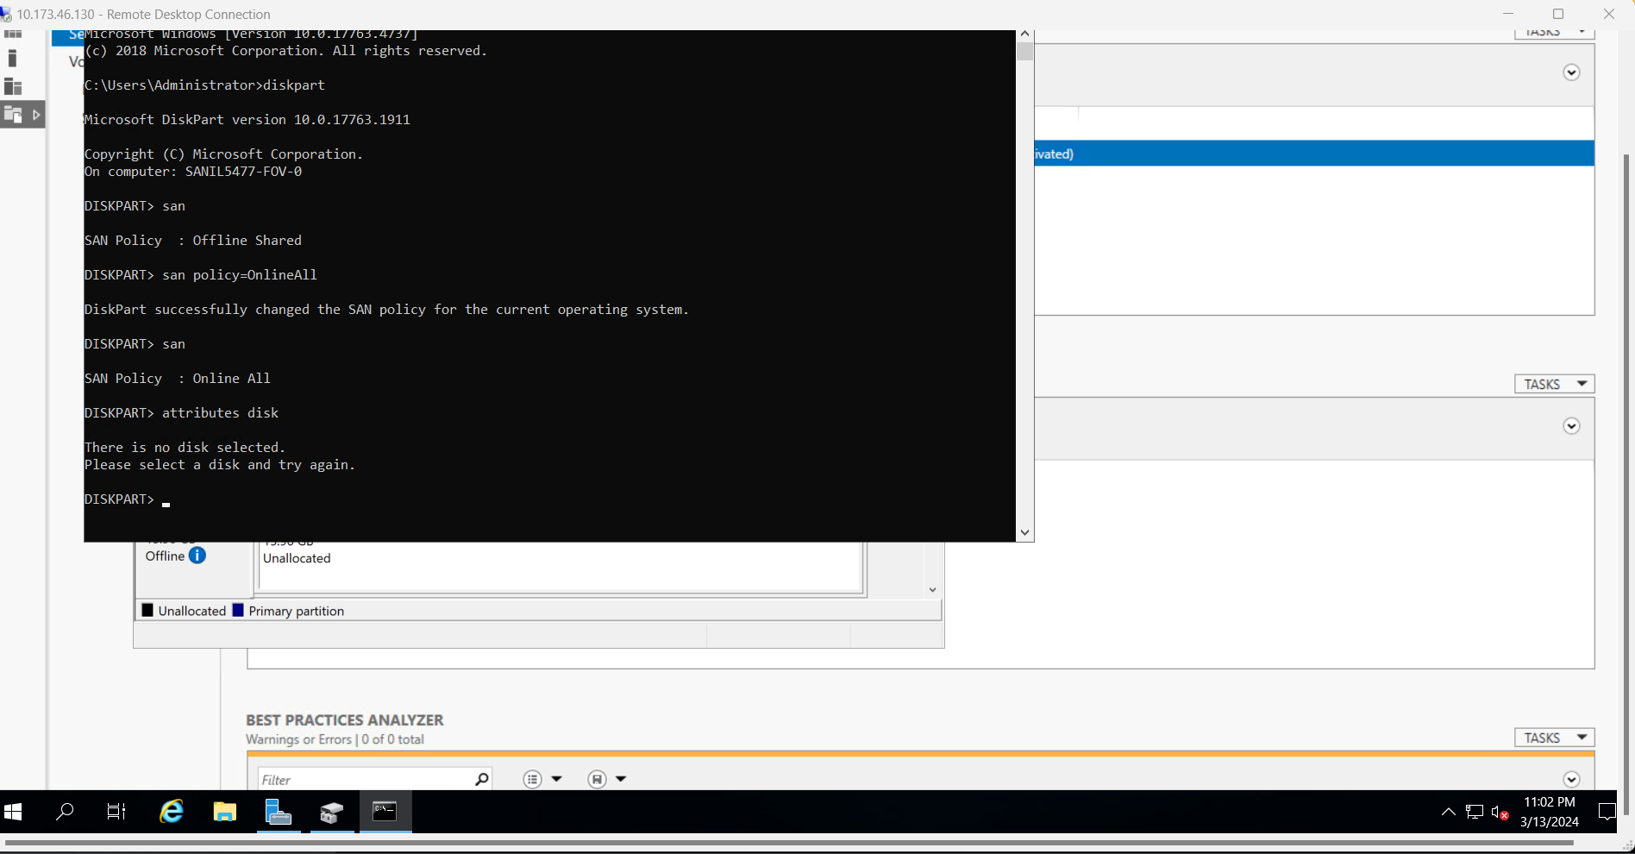

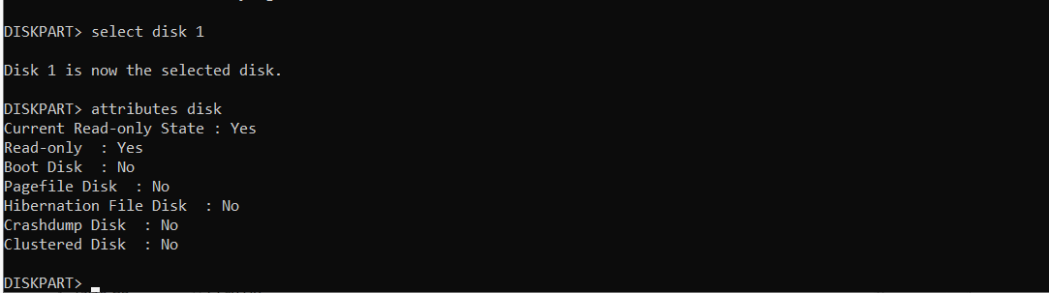

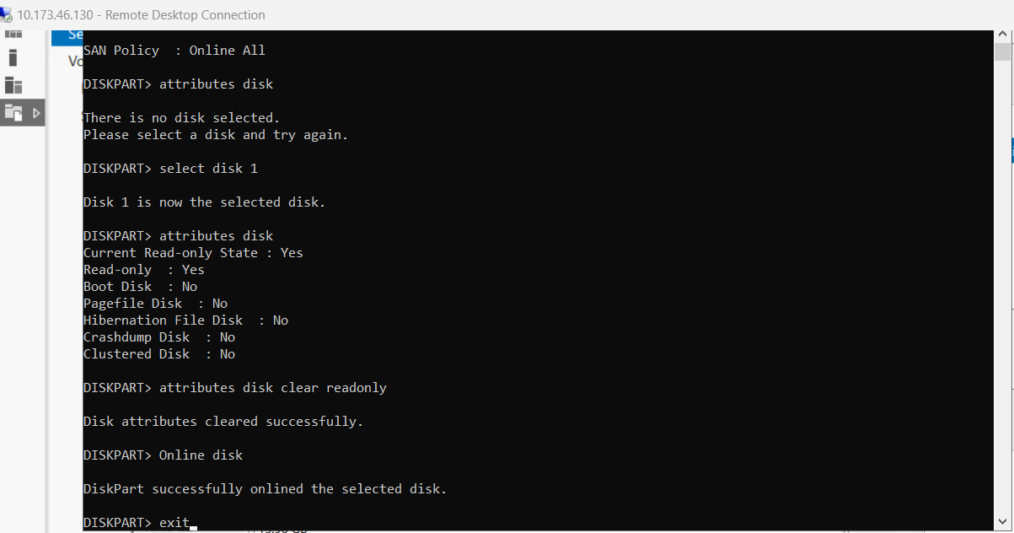

Task 6: Creating the new volume in initiator server

Creating a new volume on the initiator server serves several essential purposes.

* When you create a new volume, you’re effectively **expanding your storage capacity**. (John, 2023)
* This additional space can be used for storing data, applications, or other files.
* By creating separate volumes, you can **isolate data**.
* For example, you might have one volume for system files and another for user data.
* This organization simplifies management and enhances security.

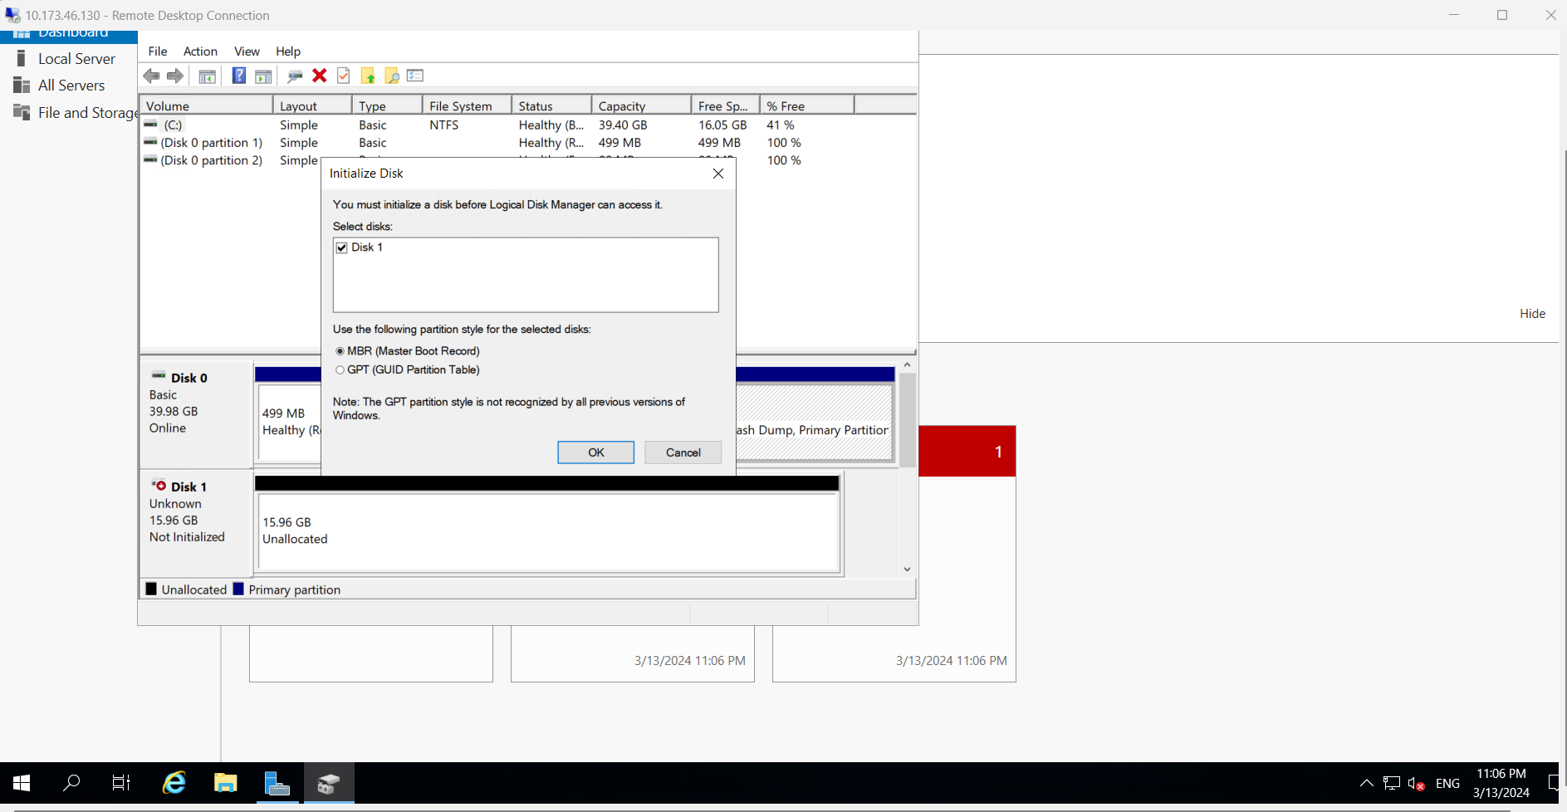

Disk 1 is online.

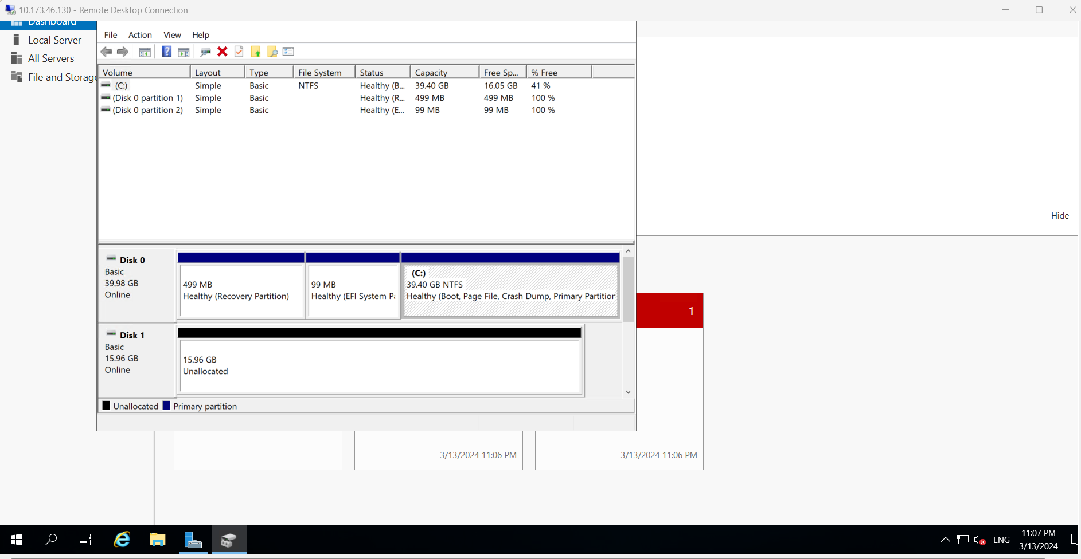

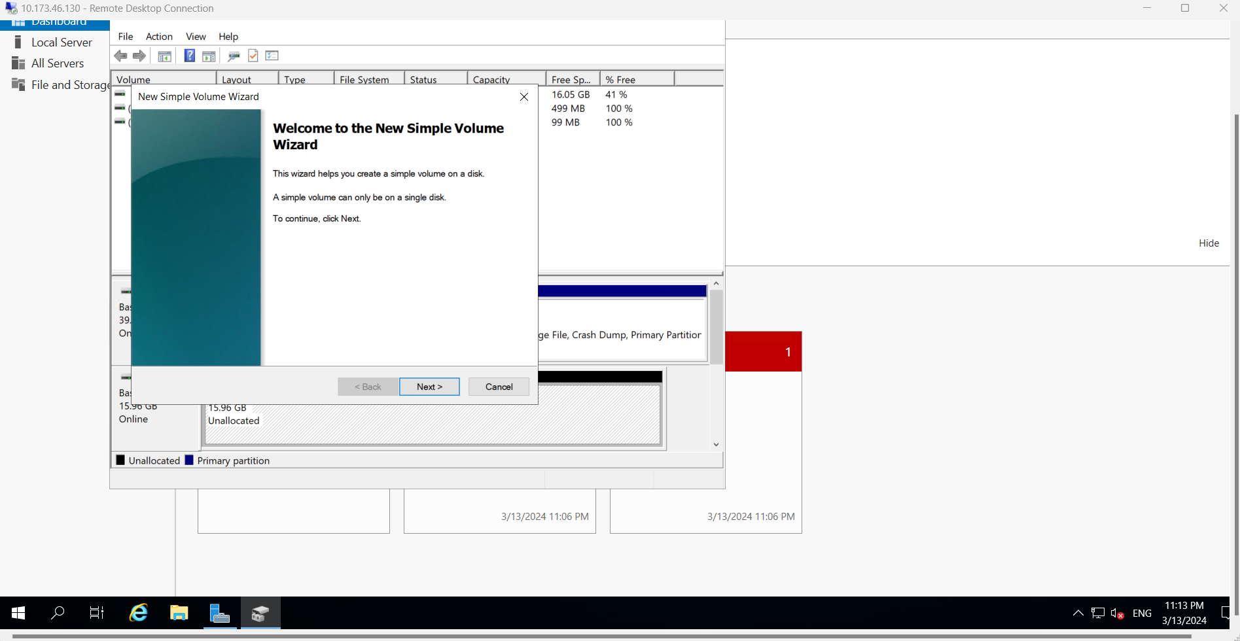

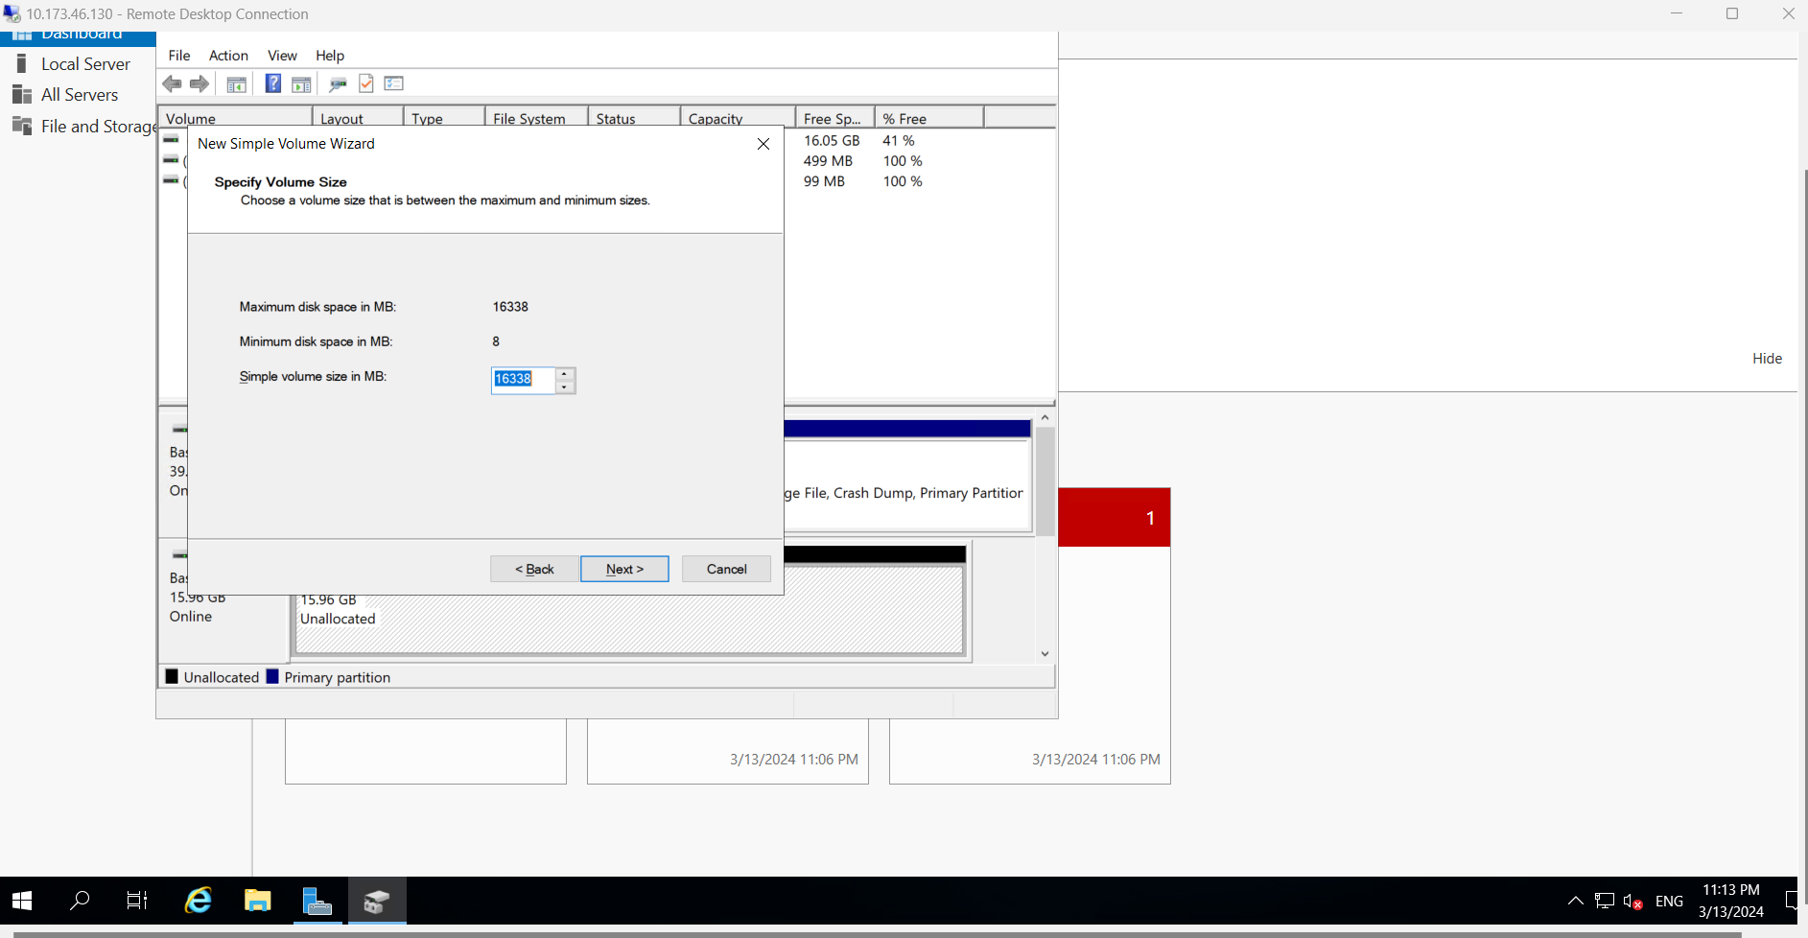

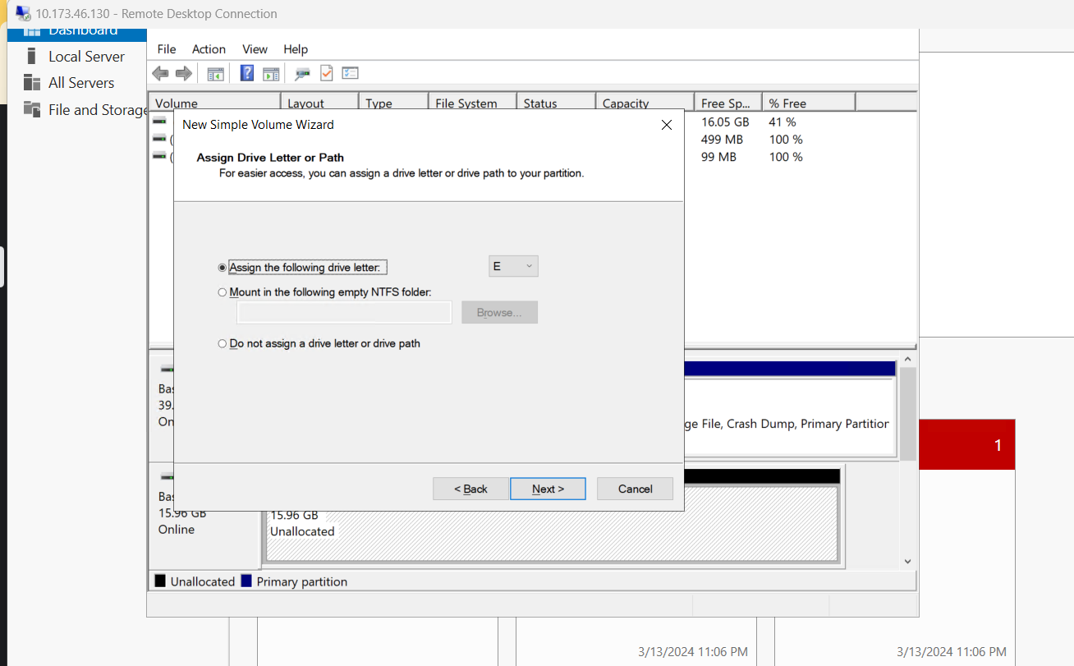

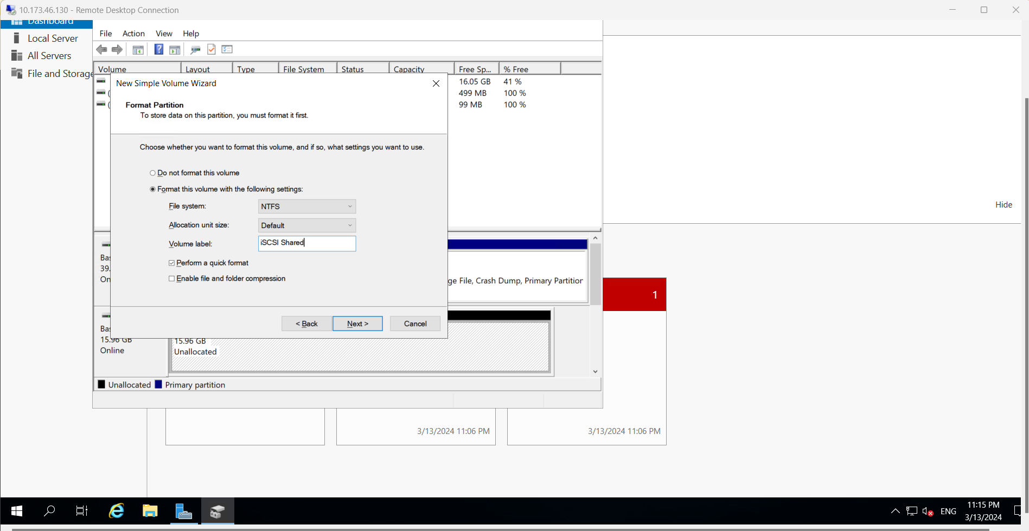

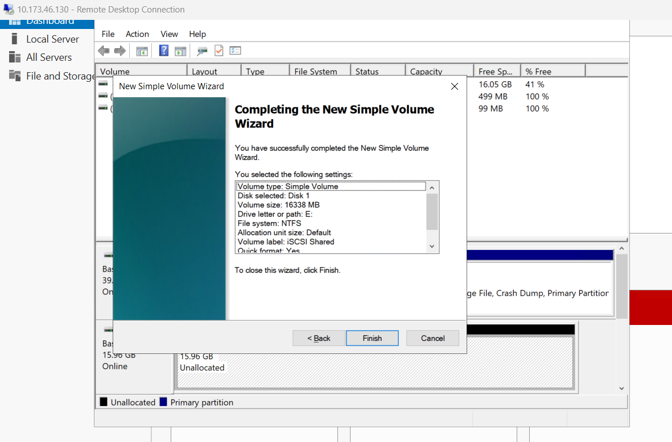

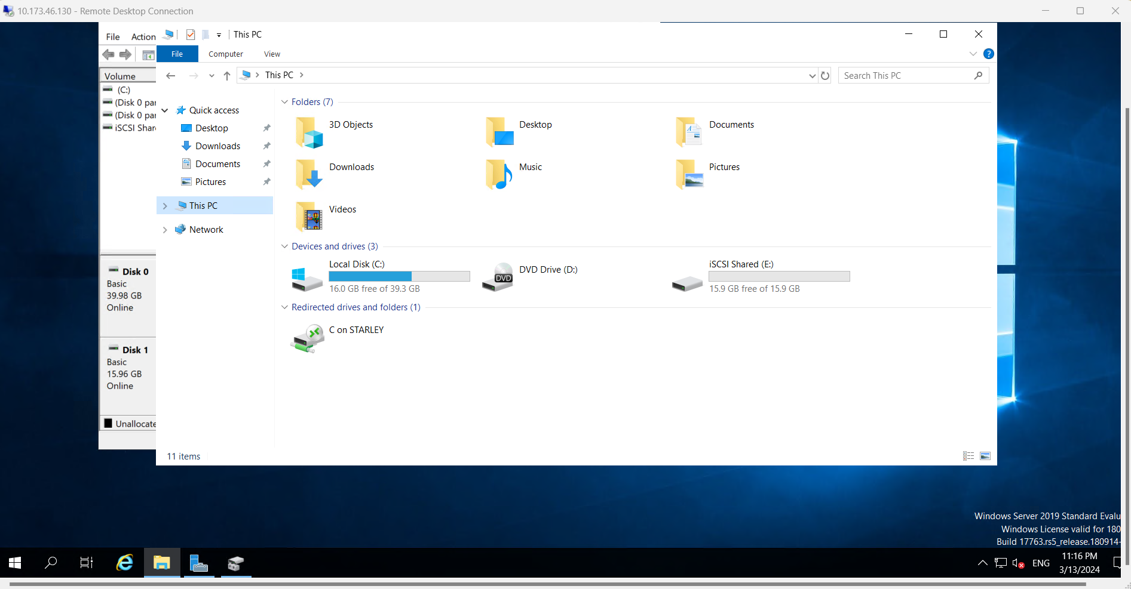

# References

John, K. ( 2023, August 17). *Configure iSCSI Initiator on Windows Server 2019*. Retrieved from Computing for Geeks: https://computingforgeeks.com/how-to-configure-iscsi-initiator-in-windows-server/

Lowe, S. (2007, July 30). *How do I… Install, configure, and use Microsoft’s iSCSI initiator?* Retrieved from TechRepublic: https://woshub.com/configure-iscsi-traget-and-initiator-windows-server/

Margaret. ( 2021, Dec 15). *What Is iSCSI Storage and How to Build an iSCSI SAN?* Retrieved from FS: https://community.fs.com/article/iscsi-storage-basics-plan-iscsi-san.html

Upadhyay, N. ( 2020, July 7). *How to configure an iSCSI initiator on Windows Server 2016*. Retrieved from SQLShack: https://www.sqlshack.com/how-to-configure-an-iscsi-initiator-on-windows-server-2016/